Aia Al-Qasab

T5616SN

Advanced Enterprise Server Environment

Lab 5

**Virtualization Lab 5. Simple VMware ESXi Host Management**

March 2019



**Lab 5.Simple VMware ESXi HostManagement**

**Step 1.Get Familiar with the ESXi Server Management Options**

* StarttheESXi-01VM and wait for the status screen to appear.

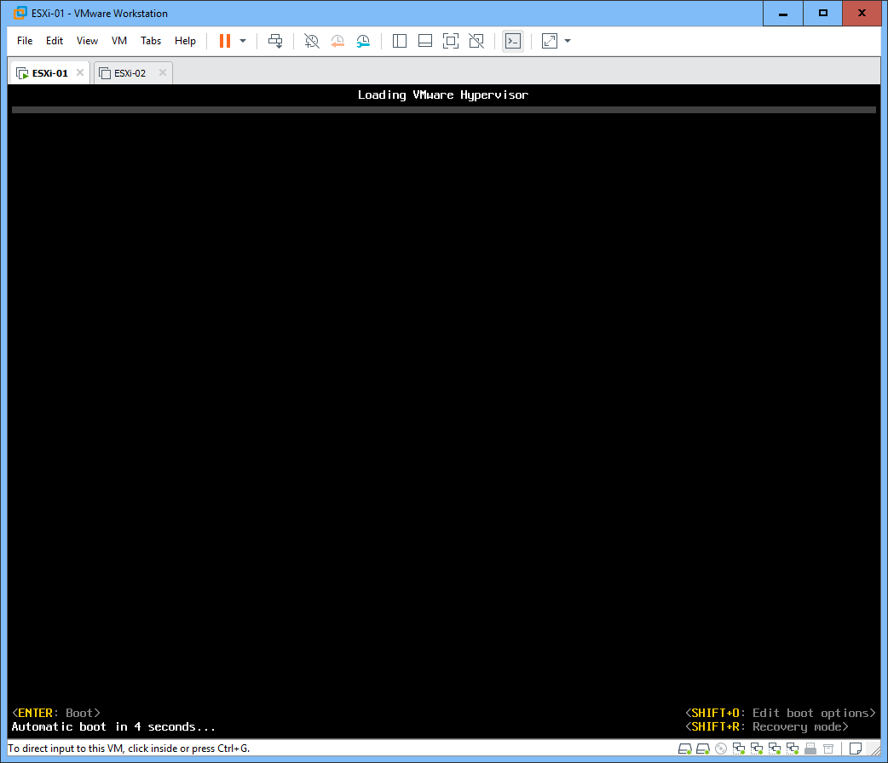

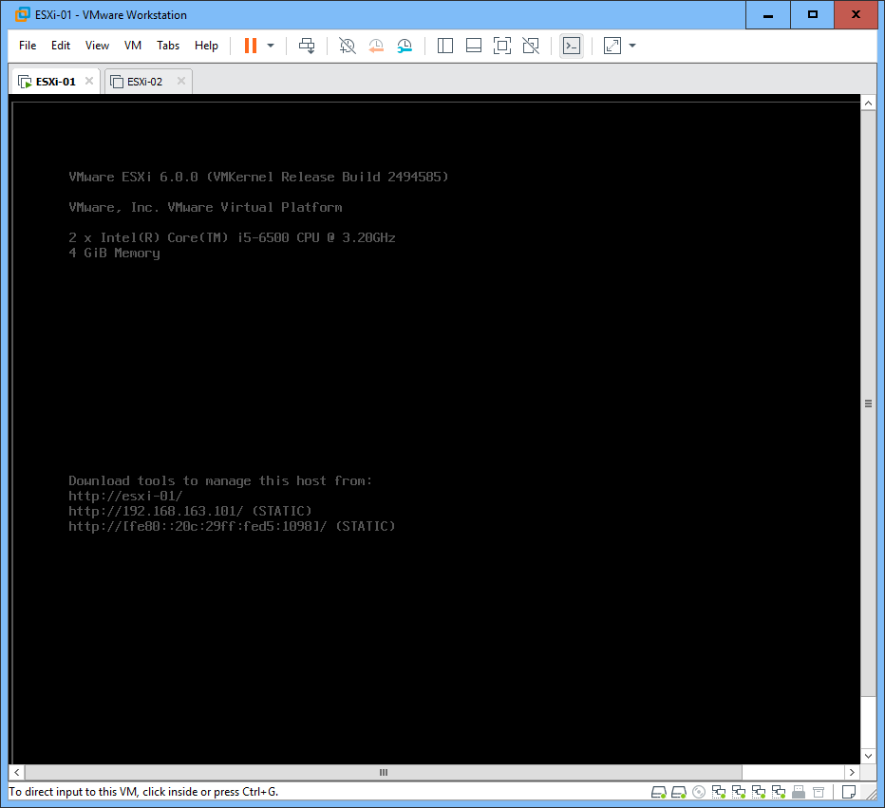

- Check the IP address of the server and browse to that address with a web browser. Investigate the information on the web page. There are different ways to **manage the ESXi servers** (hosts) remotely:

**A: 192.168.163.101**

o To manage individual ESXi servers, you are recommended to use the **vSphere Client**. However, VMware is no longer supporting the new features in the latest upgrades with vSphere Client.

o In case you need to manage multiple ESXi servers and/or need the latest features, **vSphere Web Client** is the recommended option. However, the Web Client is rather complex tool and it requires a **vCenter Server** (a platform to manage a virtual infrastructure) to be installed to a separate Windows Server, so in a smaller environments you may want to use the vSphere Client. In our lab we have the tool installed in the vCenter Server VM.

o Also check the link to the documentation. As you can see, there is lots of it!

o For administrative purposes, there are also other options:

▪ If you need automation, scripting and linking to other systems, you can use the **vSphere Remote Command Line** tools.

▪ **Web-Based Datastore Browser** allows to browse and do some simple tasks with the datastore (=data storage where the virtual machines and other resources are located) online directly with a web browser.

o Also an **SDK** is available for software developers.

In this lab, you will practice managing the ESXi servers directly and with the **vSphere Client**. In the next lab, you will do more complex things with the vSphere Web Client.

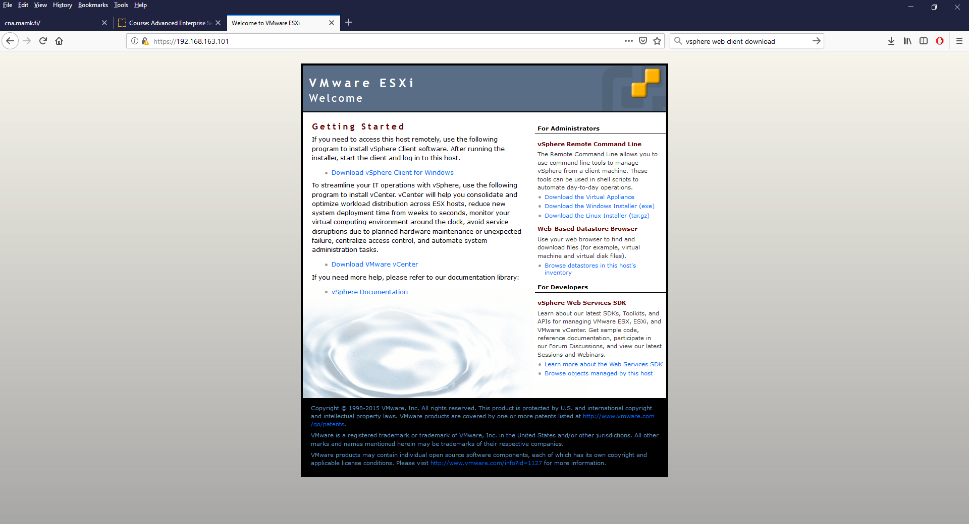

**Step 2. Check the ESXi Server Configurations**

- Check the information on the **ESXi-01** server status screen. It shows a basic summary of the server.



- Press **F2** to get to the configurations

o Login as **root** / **P@ssw0rd**

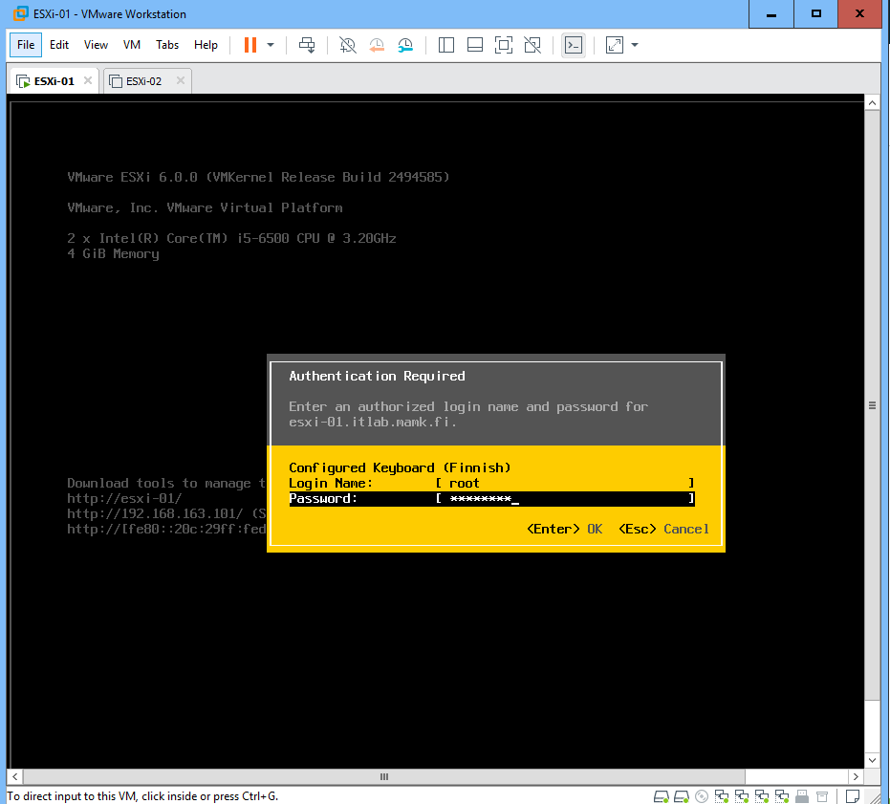

o Explore the configurations and see what kind of settings you can do here. As you can see, there are not much things to configure here. You can just set the server main settings (mainly the management network settings) and you are supposed to do all the actual management remotely.

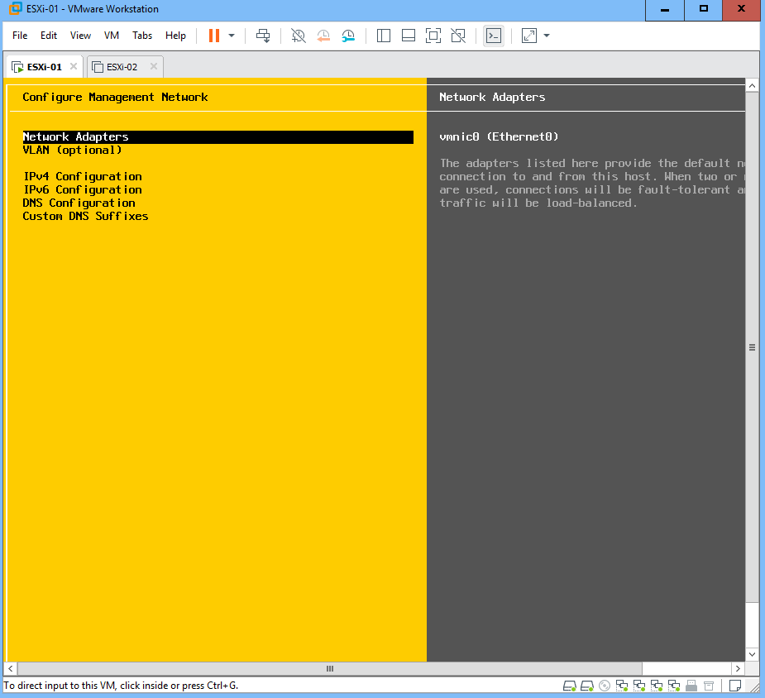

o Also take a look on the troubleshooting options. There is an ESXi Shell and an SSH Shell but by default both are disabled. In case you need to get a remote command line access to the server, these Shells make it possible.

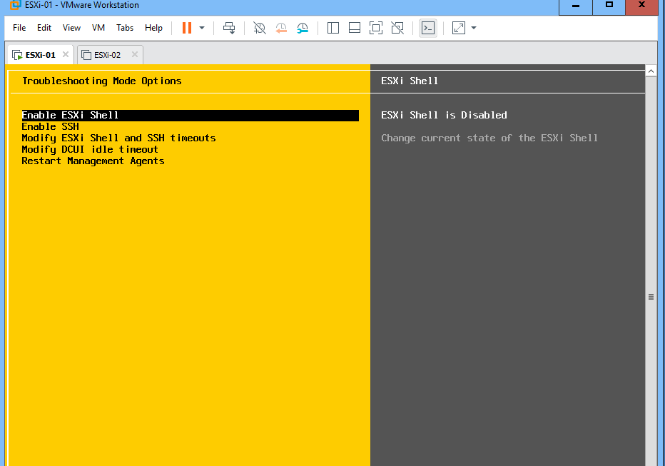

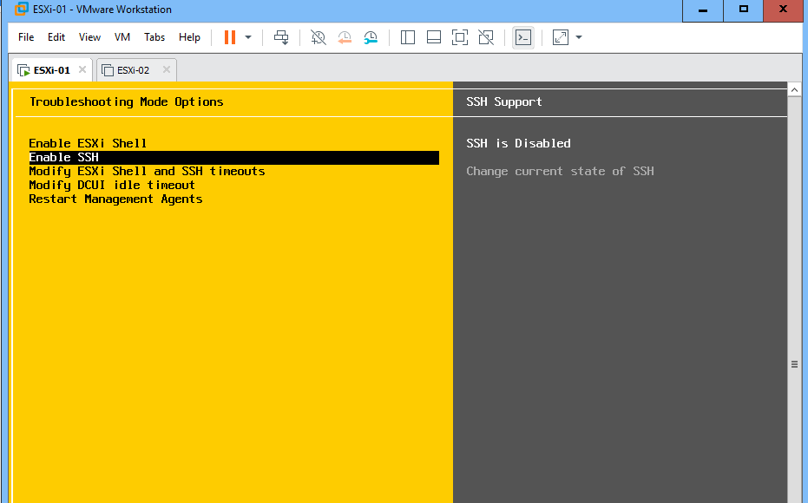

o Also check the system logs. The ESXi server operating system is Linux customized by VMware.

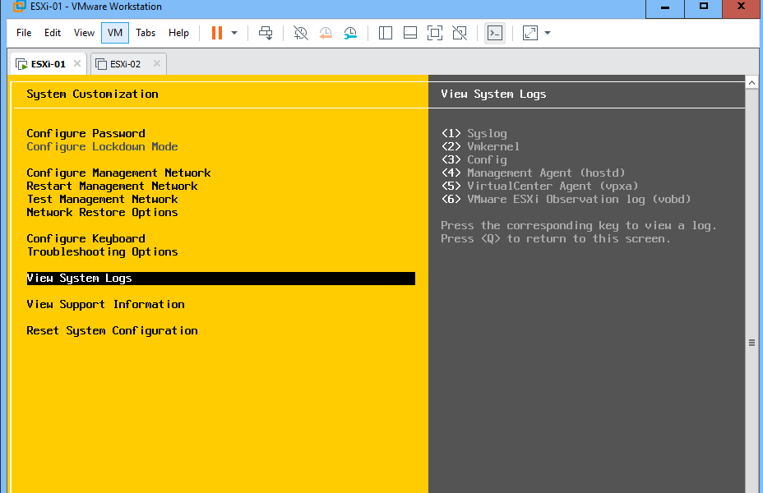

o *Select some of the previous configurations/information, attach a* ***screenshot(s)*** *of it and* ***explain*** *it in your* ***report****.*

**A: Configure Management Network use to configure and secure environments that do not permit unconfirmed hosts on the networks to be powered on. ESXI requires one IP for the management network, it use the basic settings to configure by using vSphere Client or the direct console.** **Critically important to the configuration of any ESXi environment is the proper configuration of host networking.**

o No need to change any configurations this time. When ready, you can logout.

**Step 3. Managing an ESXi Server Directly with a Host Web Client Interface**

- There is a **Host Web Client** tool to directly manage ESXi hosts with a web browser. This tool is installed in the lab ESXi servers. However, *notice that this tool is still in development and only implements a handful of the most important features*. Check the descriptions from the tool’s web page: https://labs.vmware.com/flings/esxi-embedded-host-client

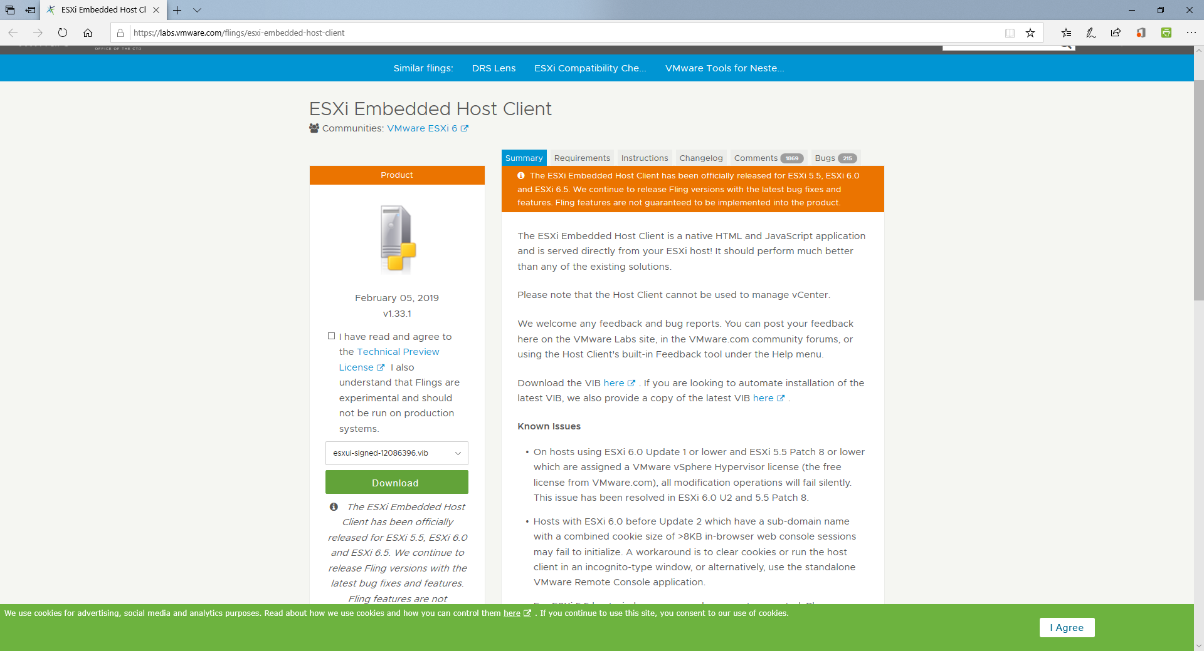

- Browse to the **ESXi-01** server’s host web client interface: https://192.168.163.101/ui

o Login as **root** / **P@ssw0rd**

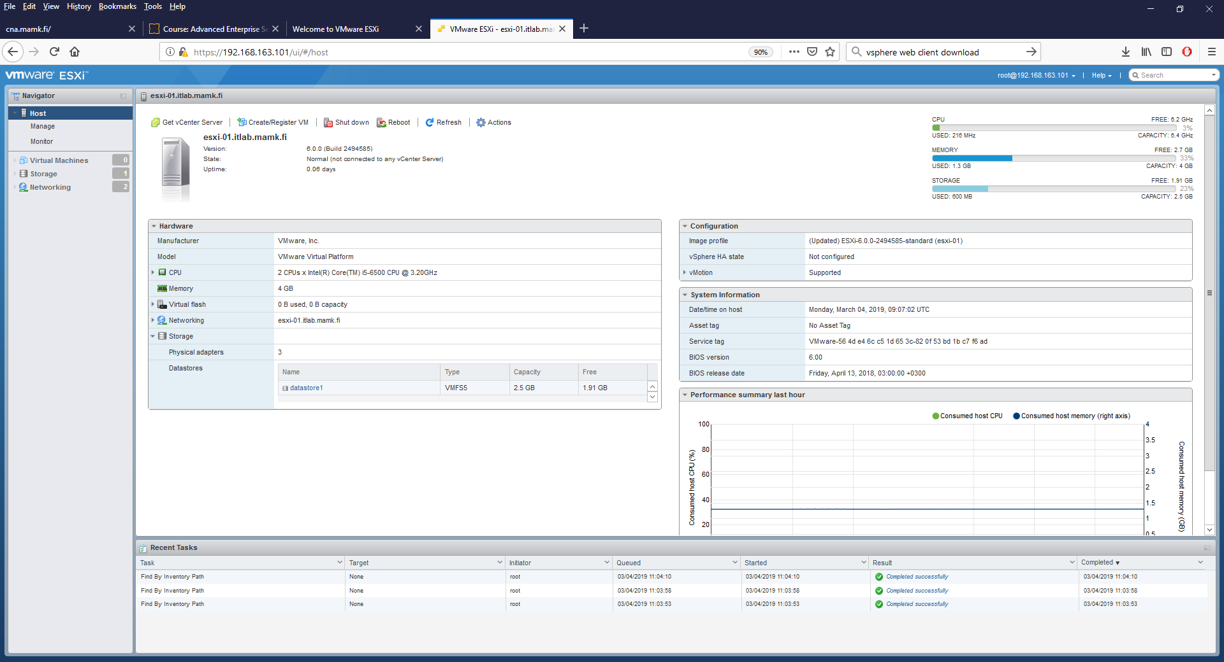

- Explore the information you can get about the **esxi-01.mamklab.fi** hosts hardware.

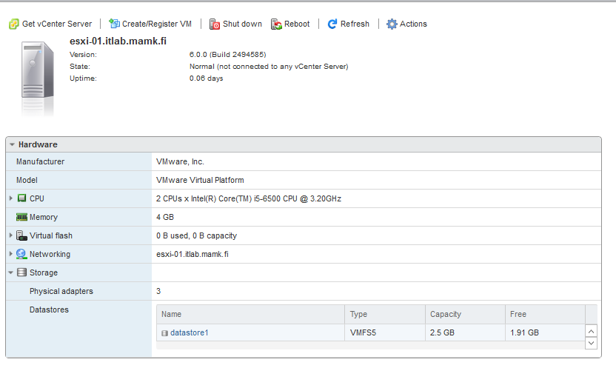

- Go to the **Storage** configurations

o Storage is configured as **datastores**, which allow storing virtual machines and other types of files.

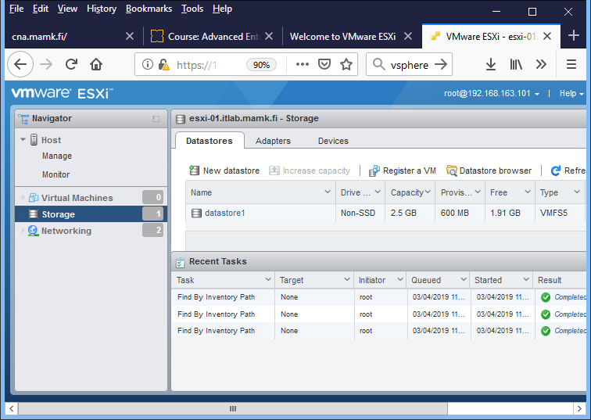

o As you can see, there is currently only **datastore1**, which is rather small.

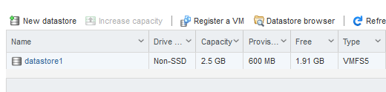

o Create a new datastore. Name the datastore as **datastore-yourname** and use the disk with 100 GB of free space. Use the full disk for the datastore.

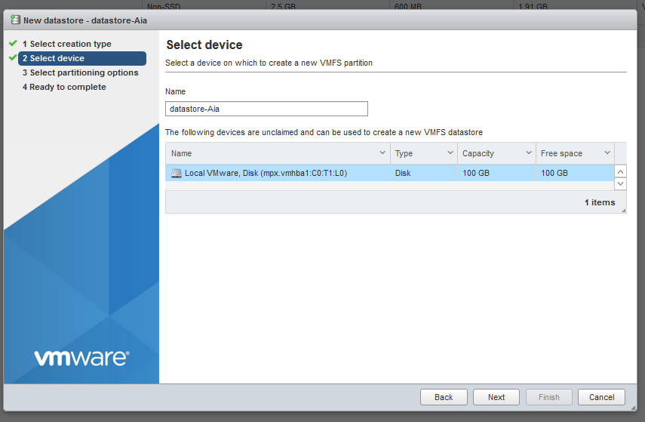

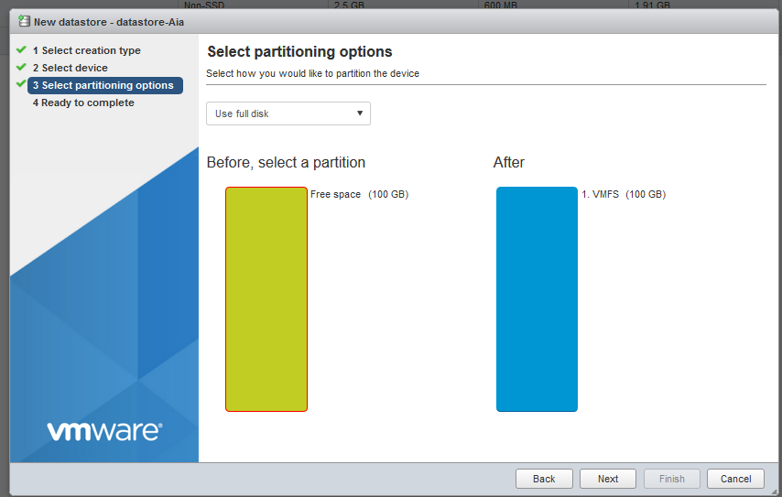

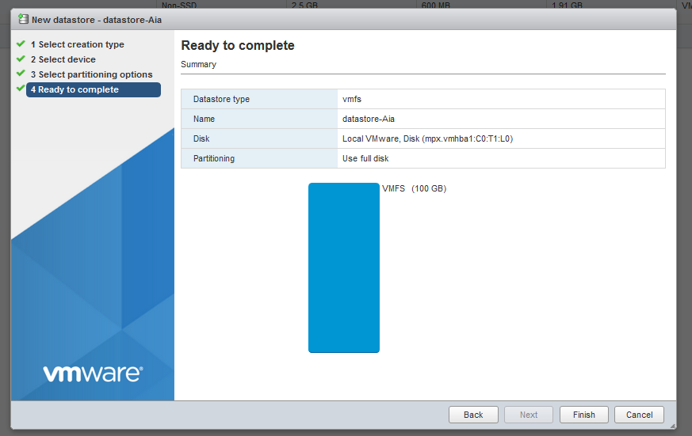

o Select your new datastore and explore the configuration options you have (including the **Actions** menu).

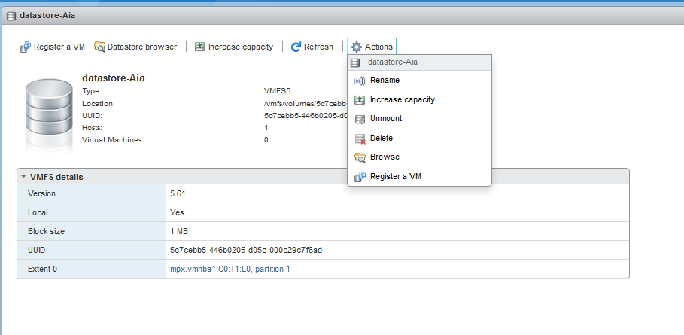

o Open the **datastore browser** and create a new directory “**Images**“ to your datastore.

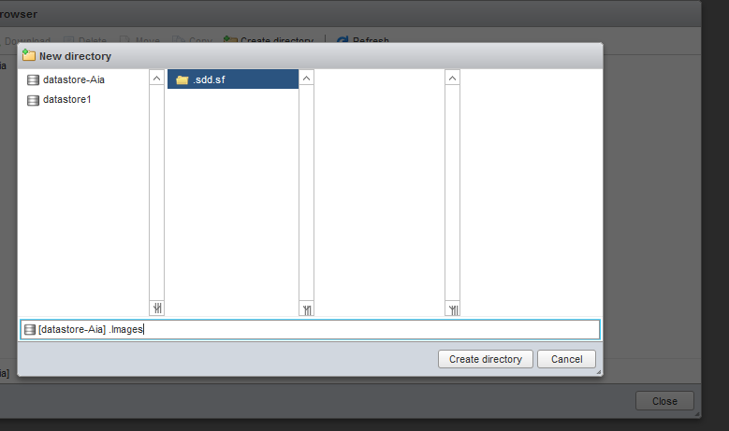

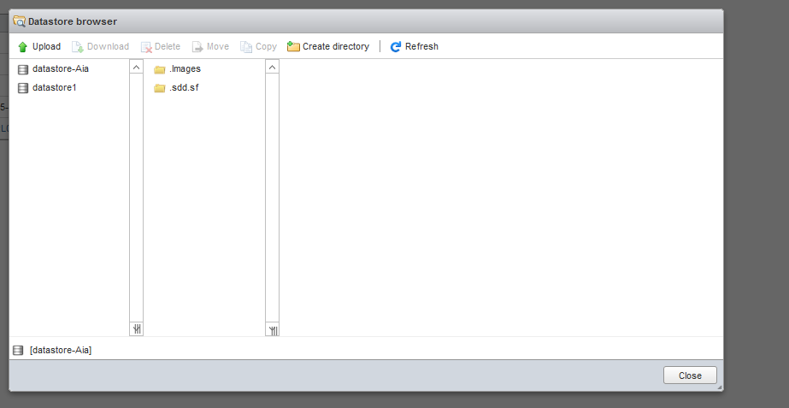

o **Upload** some ISO image to the directory (for example the Puppy Linux image from P:\Matti\ISO)

o *In your* ***report****, attach a* ***screenshot*** *of the datastore browser showing that you have uploaded the ISO to your datastore.*

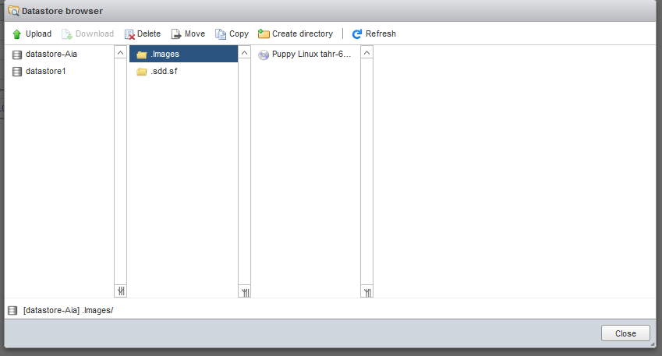

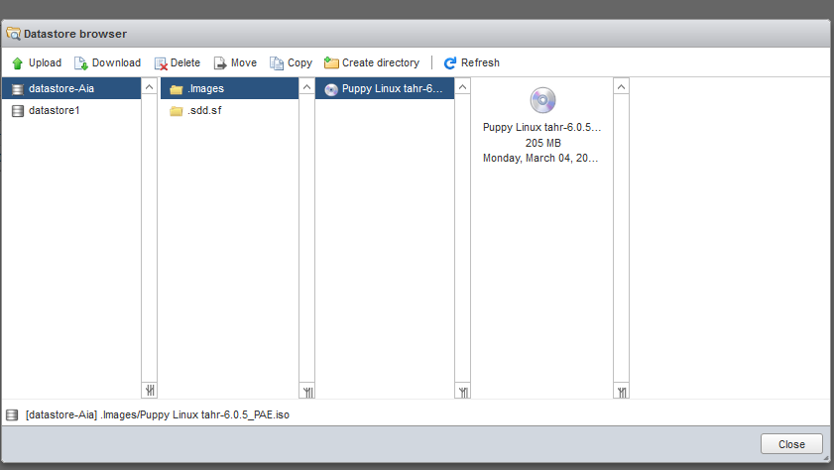

- Then, check the **Networking** configurations

o Notice that by default, there are two networks (listed as port groups): **VM Network** and **Management Network**.

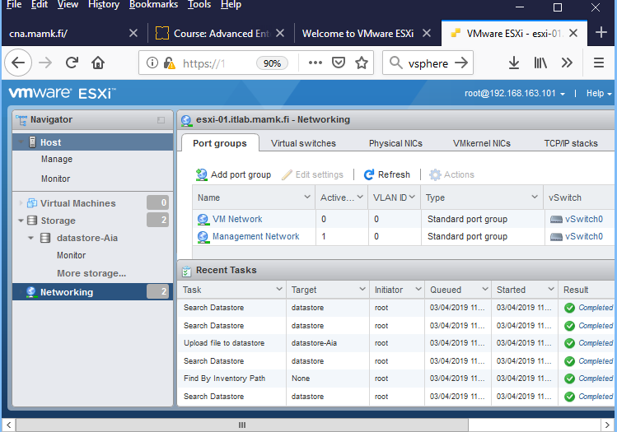

▪ *In your* ***report****, explain* ***what*** *are these networks used for and* ***why*** *they are separated?*

**A: Virtual machines connect to a network much in the same way physical ones do. The difference is that the VMs use virtual network adapters and virtual switches to establish connections with physical networks. Generally, host networks include storage, vMotion, VM, and management networks. These are generally the basic networks configured in order to have a functioning ESXi cluster that is integrated with the vCenter server.**

o Notice that the VM Network currently has no active ports as there are no VMs connected to the network.

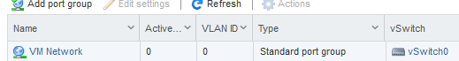

o Check the virtual switches tab. There is currently one standard virtual switch: **vSwitch0**.

o Check the vSwitch0 Details: the switch has 1536 ports.

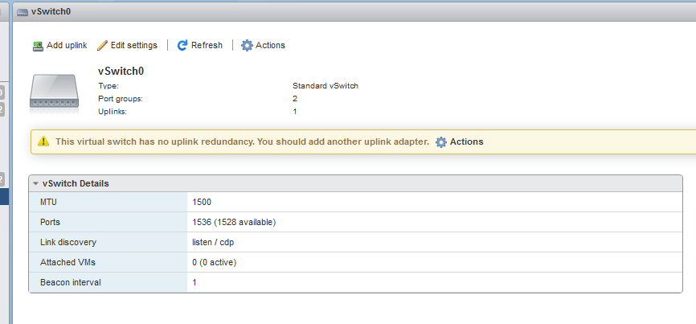

o Go to the **vSwitch0** settings and notice the warning that there is no uplink redundancy. Add all three available NICs to the switch.

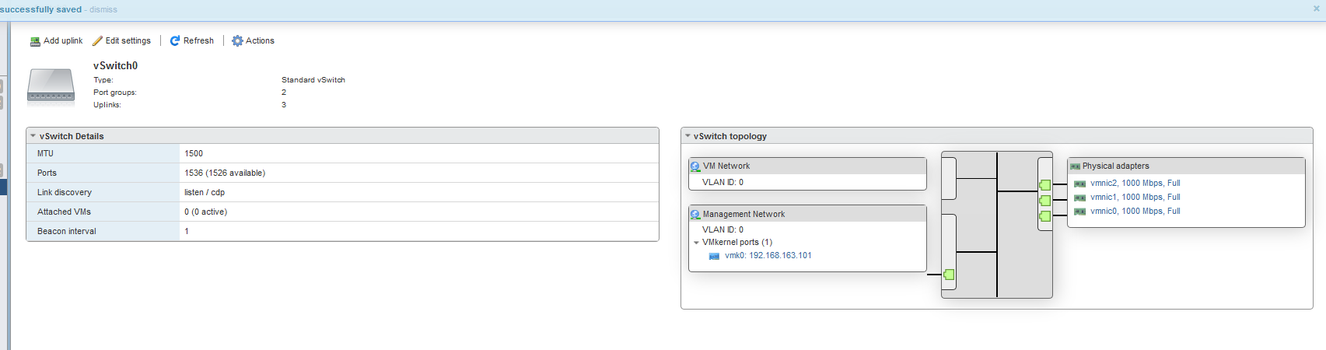

- **Create a new VM** using the ISO image you uploaded to the datastore.

o VM name should include **your name**.

o The Puppy Linux image is 32-bit, Ubuntu compatible.

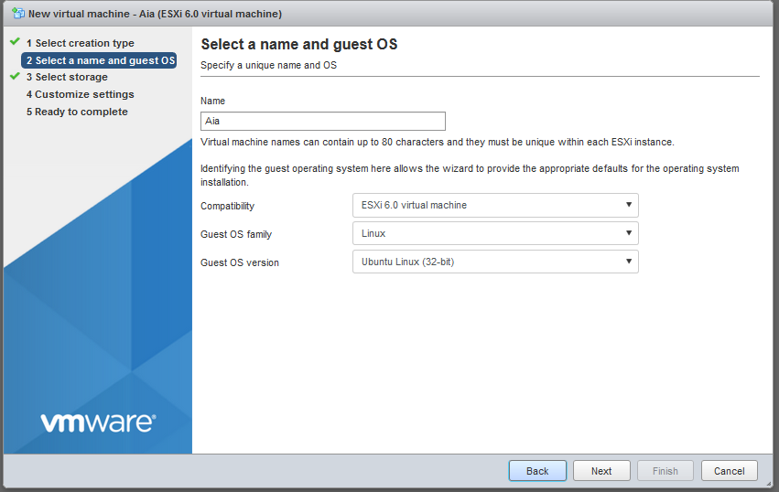

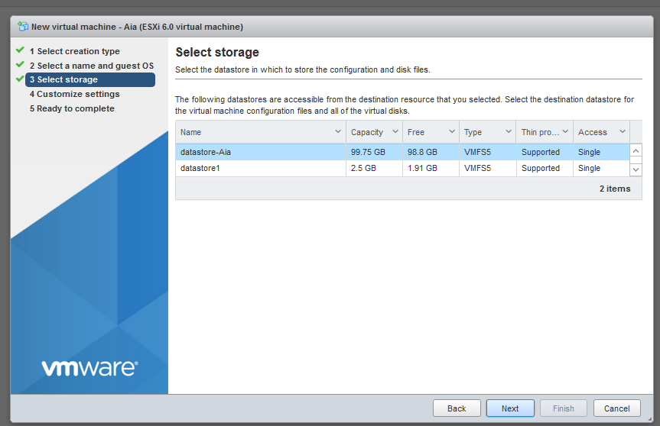

o For the Virtual Hardware, the Puppy will be happy with 256MB of RAM and 2 GB of HDD.

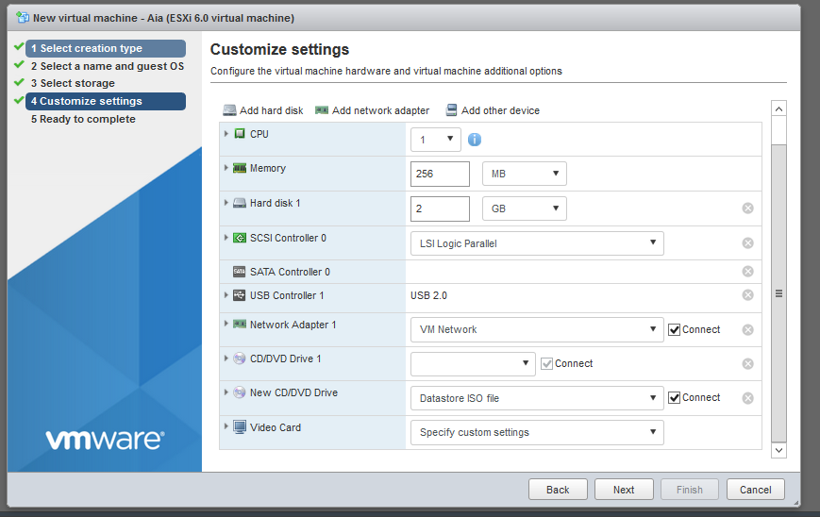

o Also check the VM Options.

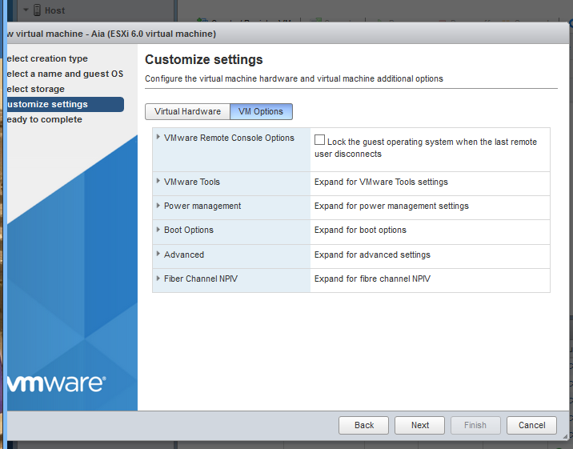

o When ready, open the **Virtual Machines** configurations from the left pane and browse to your new VM.

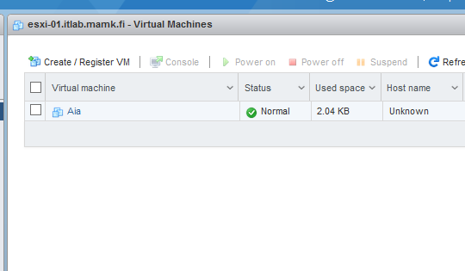

o Check the virtual machine information page and see what kind of details you get from the VM.

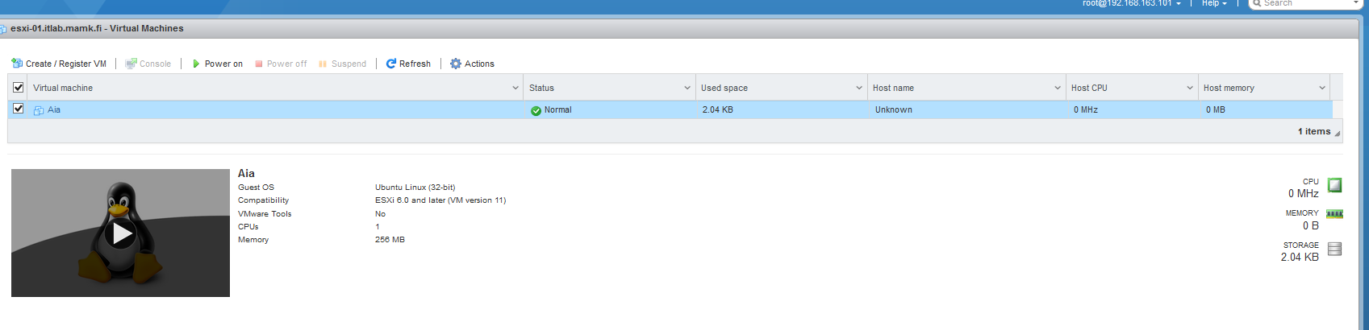

o Power the VM on and open a **Console** to the VM.

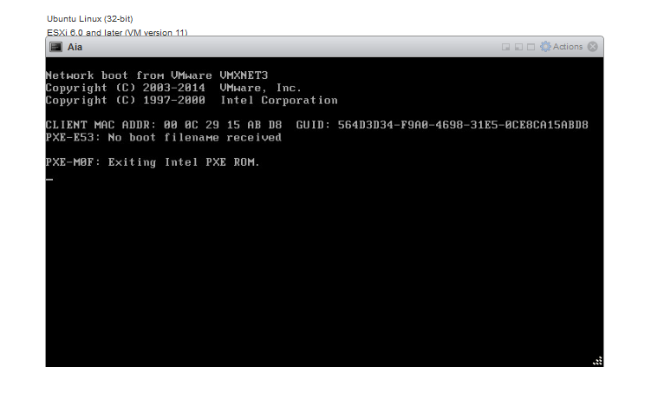

o The graphical system probably doesn’t start automatically but you can test pinging some web service (like google.fi) to verify that the guest OS is running ok and network connection is working.

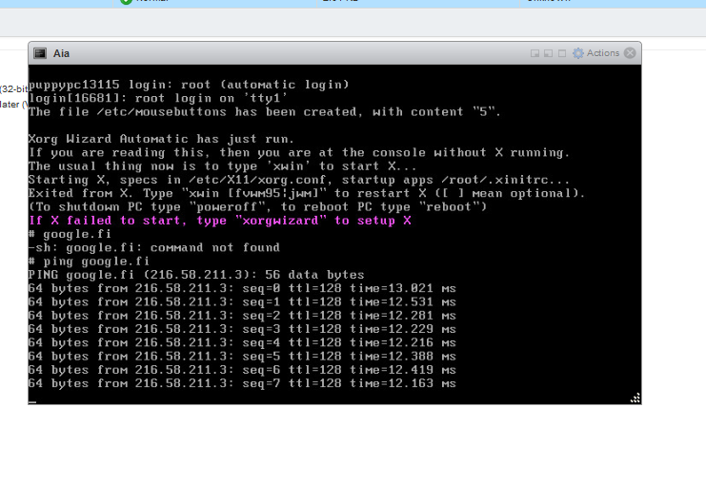

o Close the console and practice opening different types of consoles to the same VM. Especially the **remote console** is very handy.

o In the remote console, configure the graphical UI (run xorgwizard, do the settings and start the X with xwin)

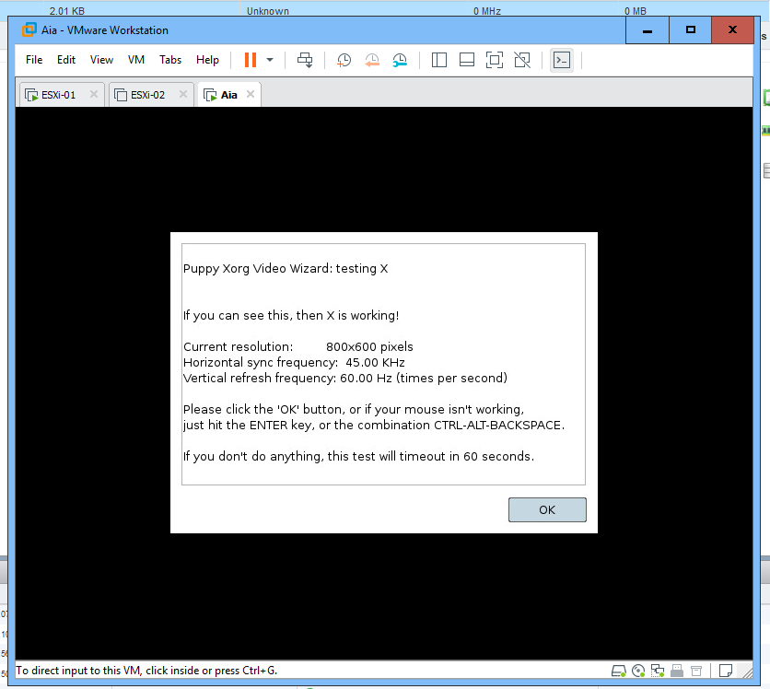

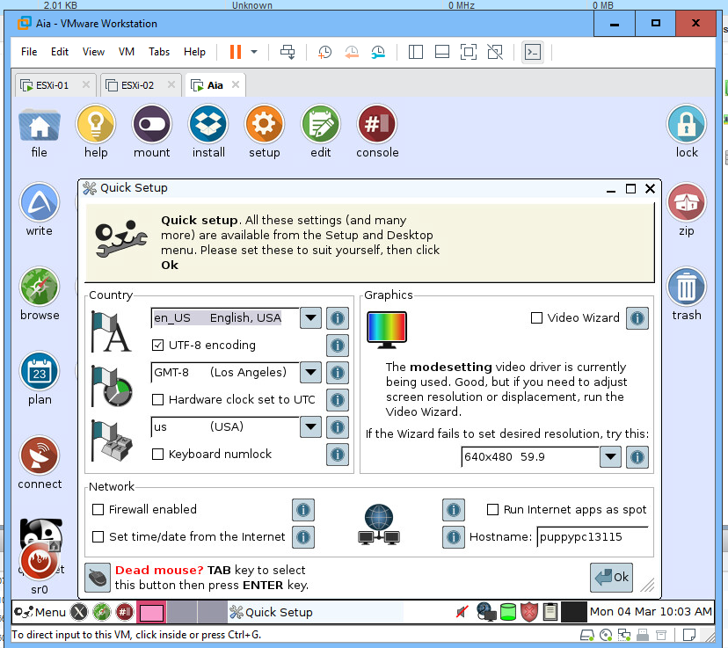

o There is no need to install the OS to the hard drive, just use the system from the ISO image.

o Again, check the virtual machine information page and note especially the resource consumption information. *Attach a* ***screenshot*** *of the VM information page to your* ***report.***

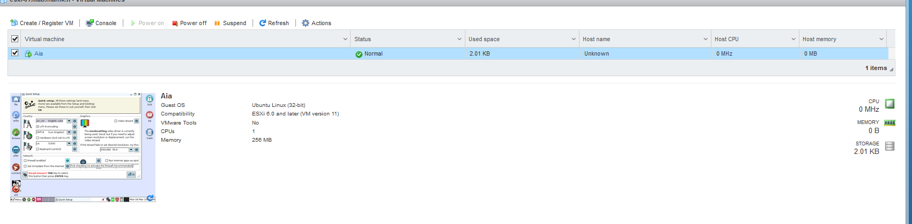

- Leave the Host Web Client interface running and continue with the next step…

**Step 4. Managing ESXi Servers with the vSphere Client**

- Remind that the **vSphere Client** is the tool for managing individual ESXi hosts and doesn’t support all the new features. But the tools is very handy (and **free**!) for smaller environments.

- Install the vSphere Client to the local computer. You can find the installer from P:\Matti\VMware Software\VMware-viclient-all-X.X.X-XXXXXXX.

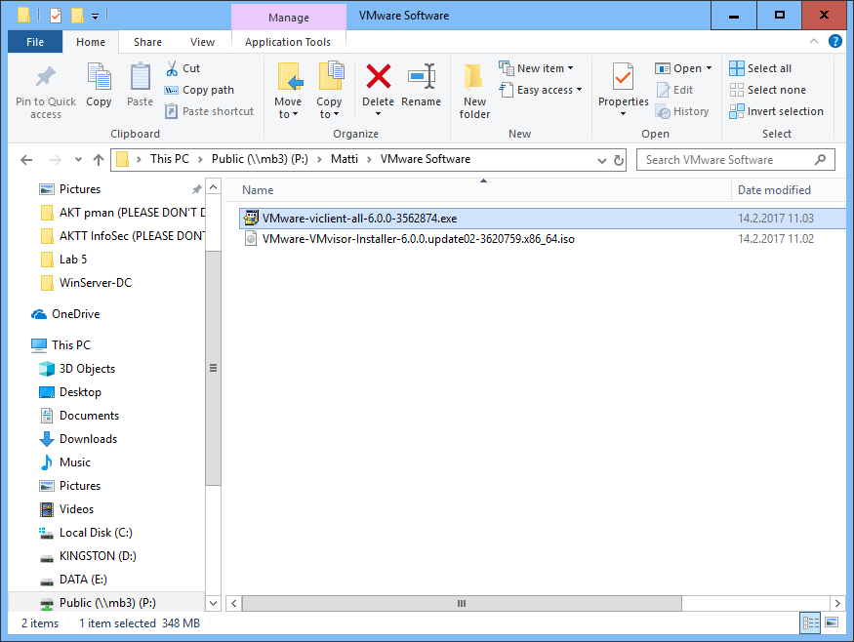

- While installing, start the **ESXi-02** VM and wait for the **status screen** to appear.

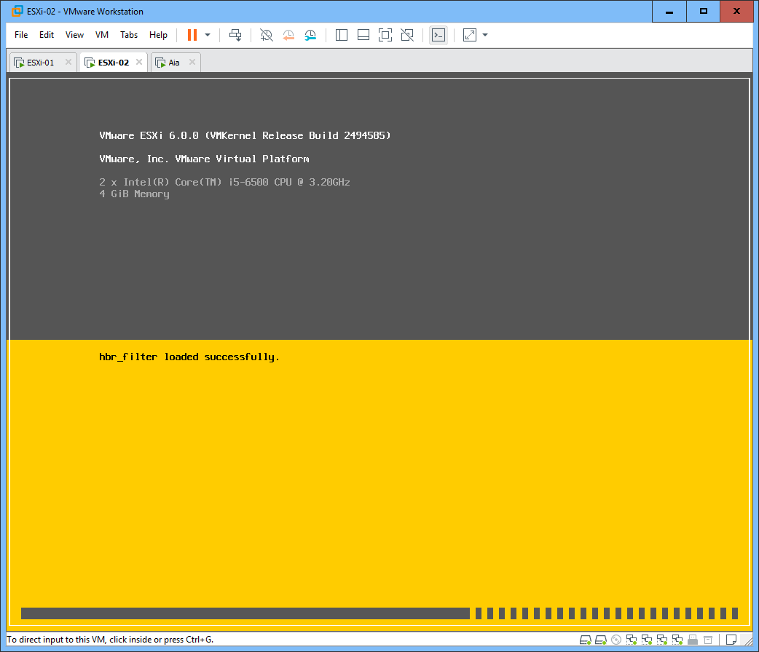

- Open the **vSphere Client** and open a connection to the **ESXi-02** host (192.168.163.102) as **root** / **P@ssw0rd**.

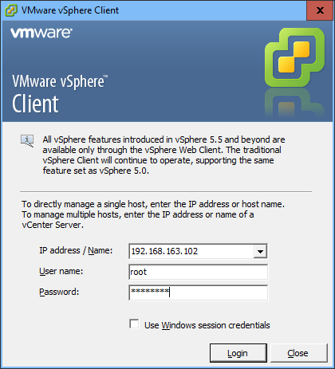

o Ignore the certificate warning (the lab VM doesn’t have a valid certificate). You can also select “Install this certificate and do not display…” to prevent getting this message again.

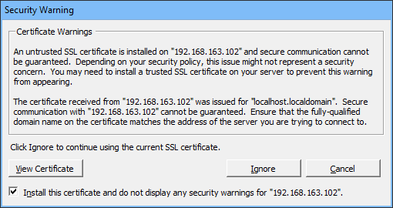

o Also accept the message telling about evaluation period. In the lab environment we are using evaluation versions of the products, which provide full functionality for a limited amount of time.

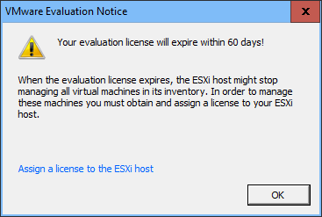

- Go to the **Inventory** and browse through the **configuration tabs**

o **Getting Started** (can be closed for the future, if you wish): how to begin working with the vSphere Client and links for the documentation.

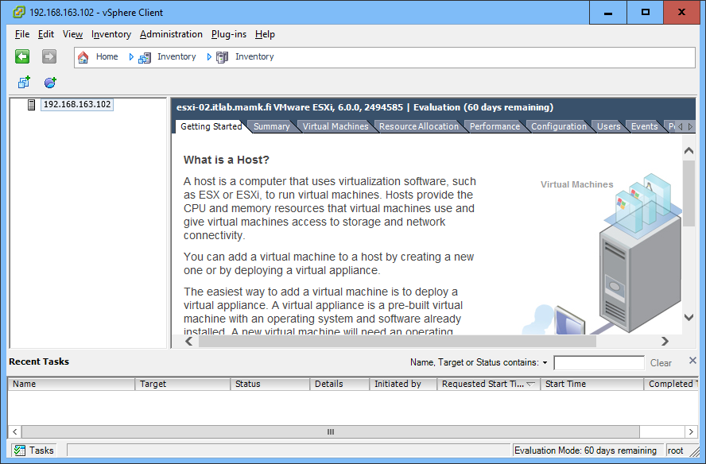

o **Summary**: overview of the current system and main controls.

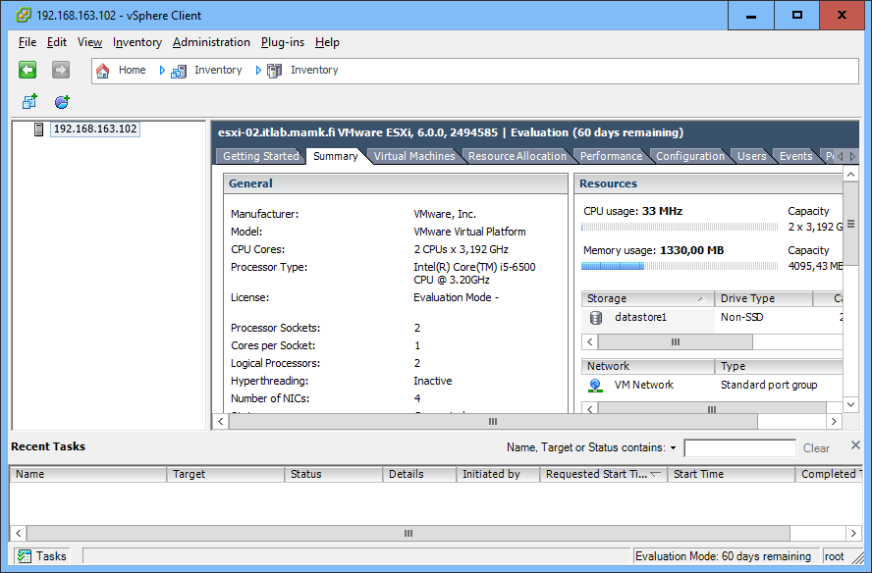

o **Virtual Machines**: list and details on each VM (there are no VMs yet).

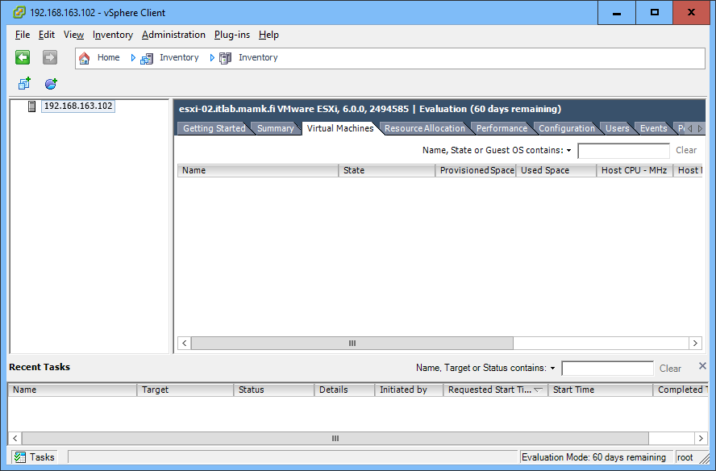

o **Resource Allocation**: allocation of the host (server) resources.

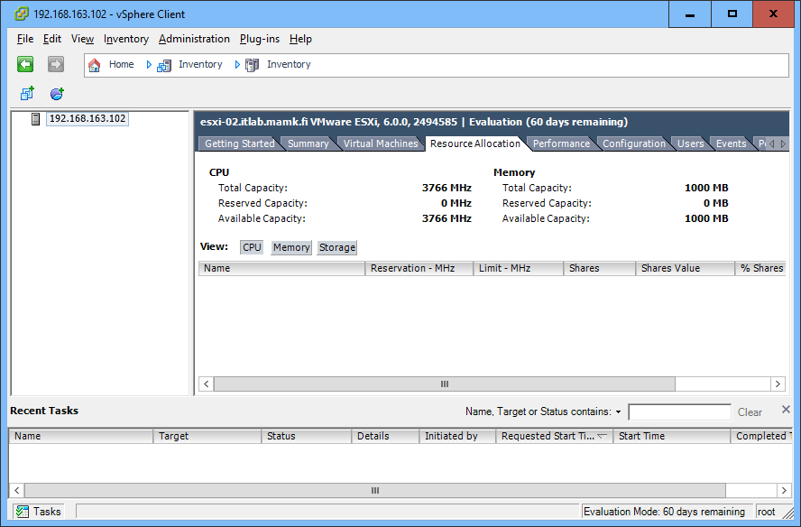

o **Performance**: monitoring the host resource usage

▪ Check the **Switch to** menu and browse some details on the resource usage.

▪ Check the **Chart Options** and customize some charts based on your preferences.

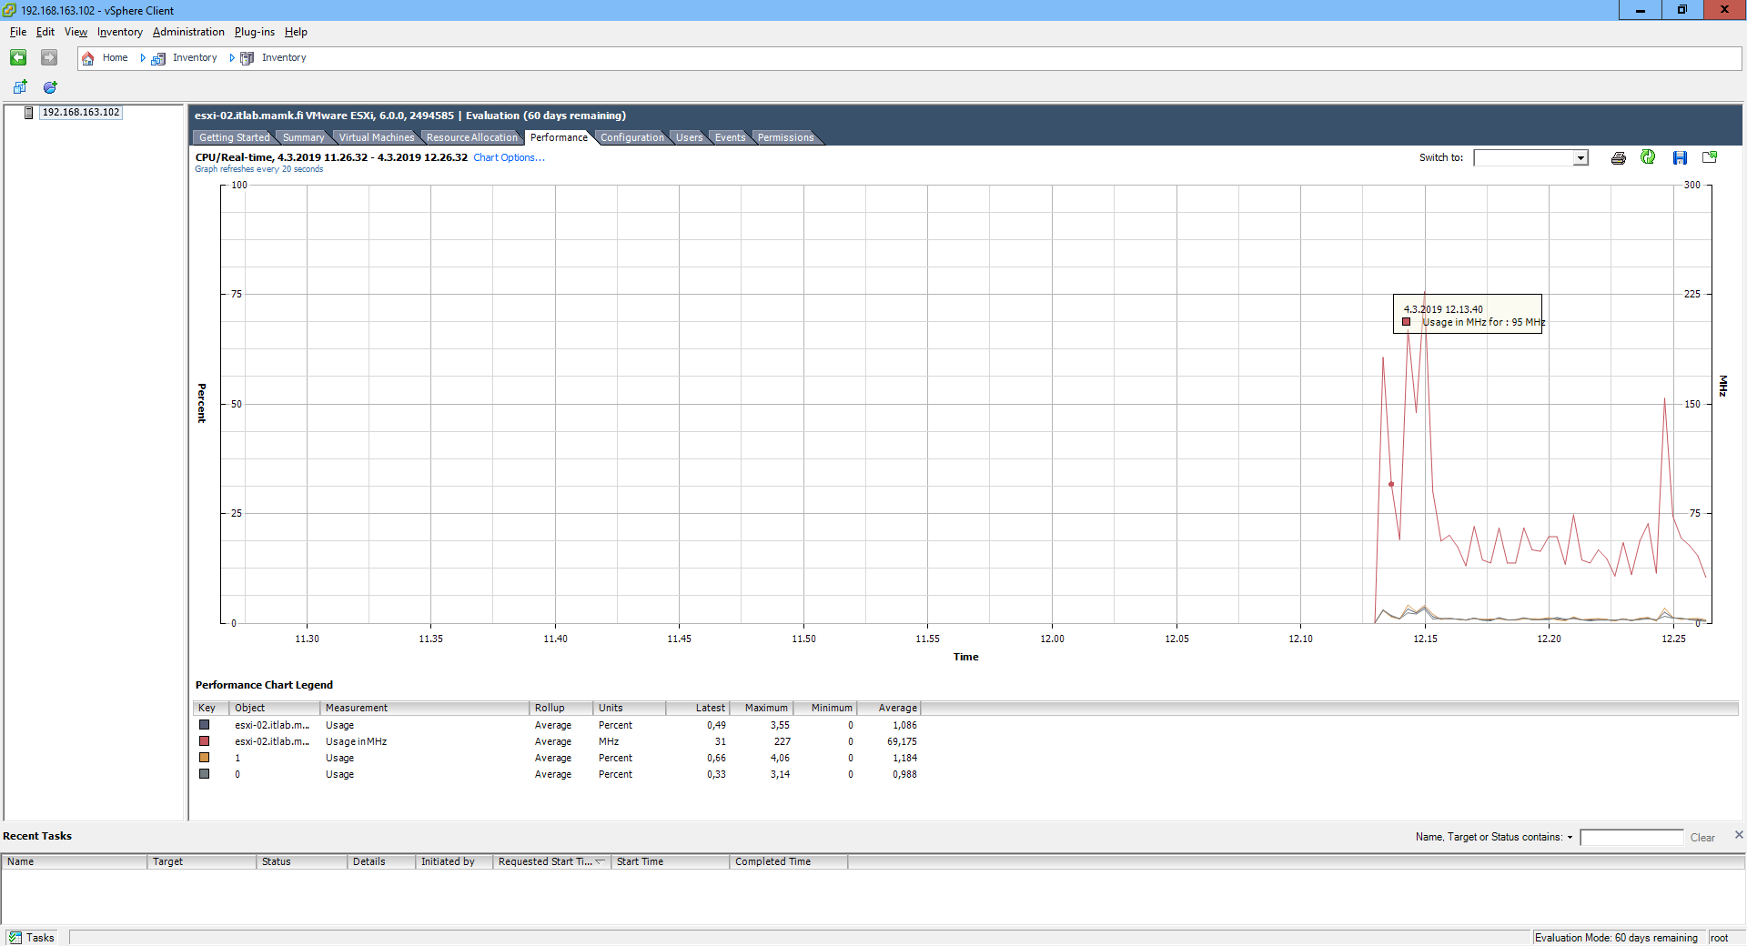

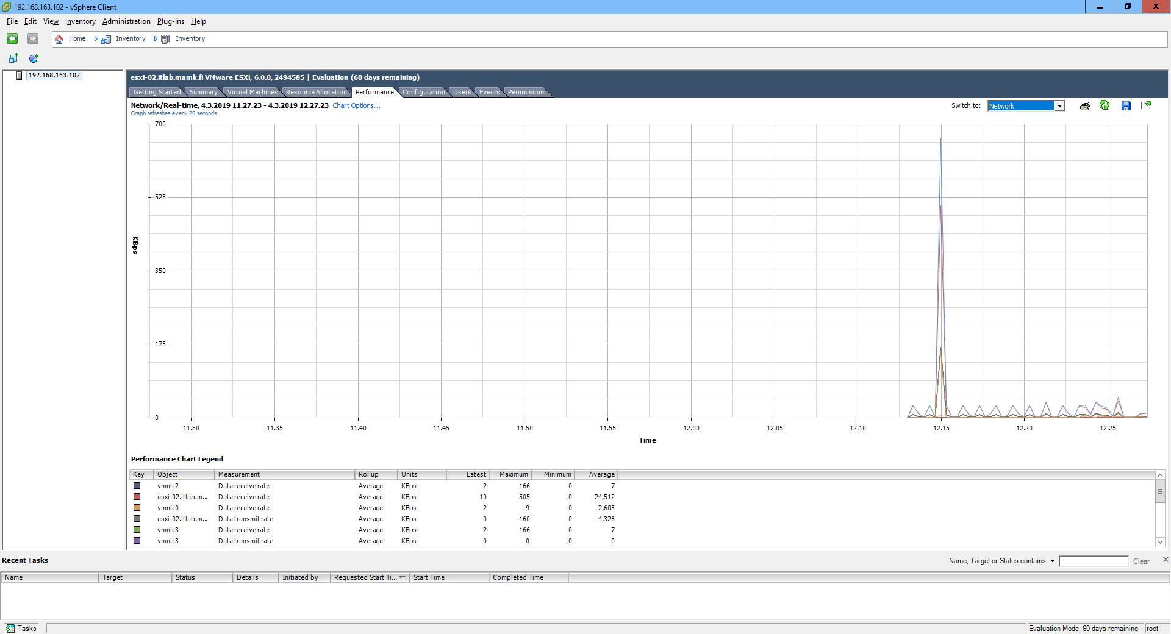

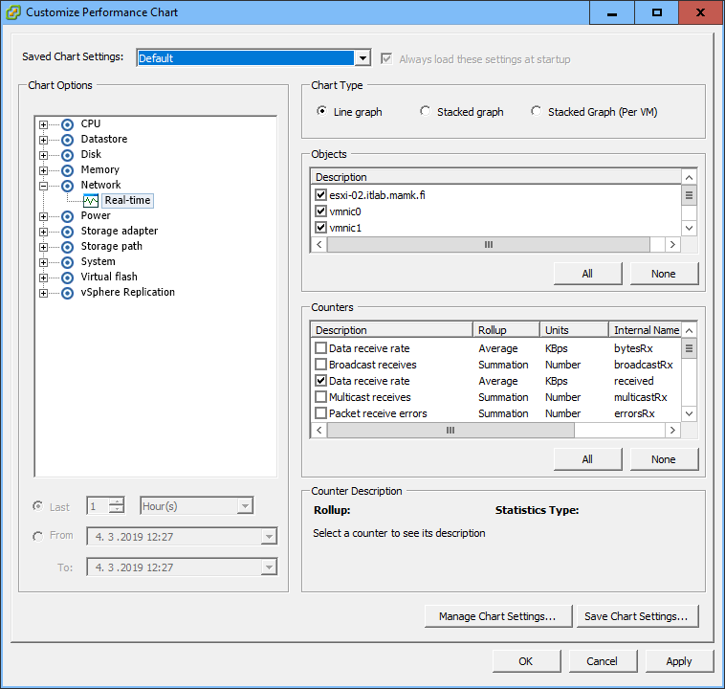

o **Configuration**: the ESXi hosts hardware and software configurations. Browse through the information (no need to do anything yet) and check especially

▪ **Storage**: check the **datastore1** information and Details, get more information by right-clicking, etc.

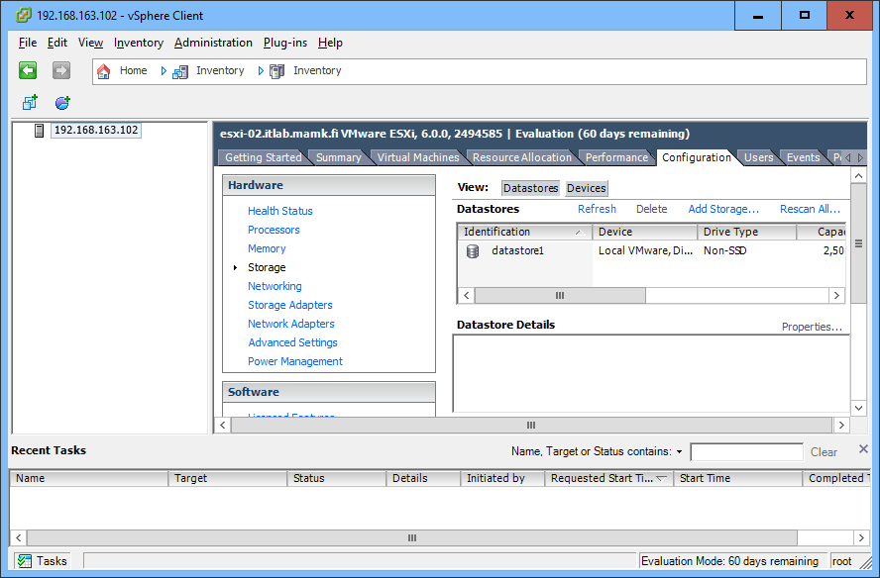

▪ **Networking**: check the virtual network structure and **vSwitch0** properties

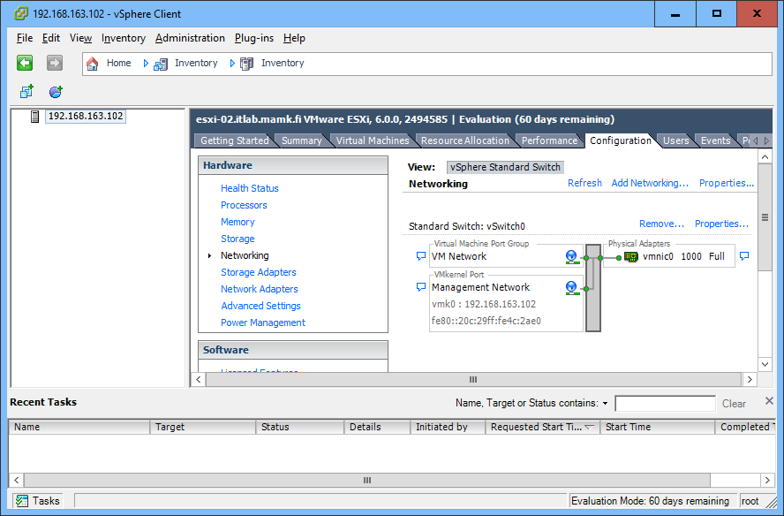

▪ **Licensed Features**: we are using the Evaluation Mode with full product features available (after the license expires most of the features will be disabled).

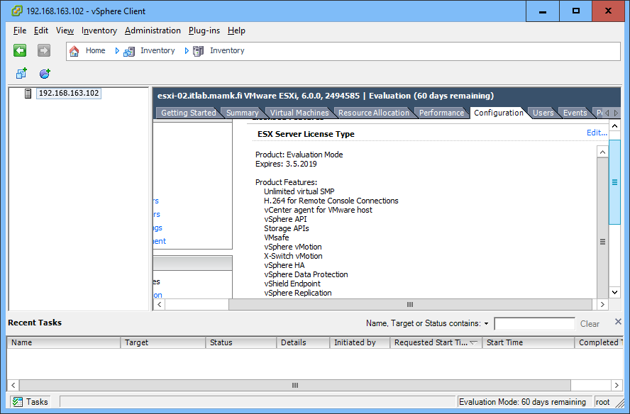

▪ **Time Configuration**: it important to keep server clocks synchronized-

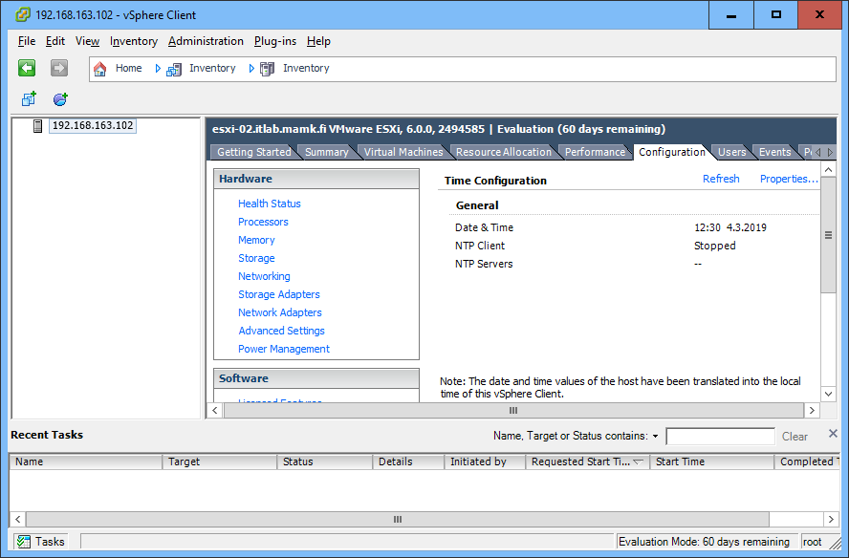

▪ **Authentication Services**: here you can configure domain authentication, if preferred

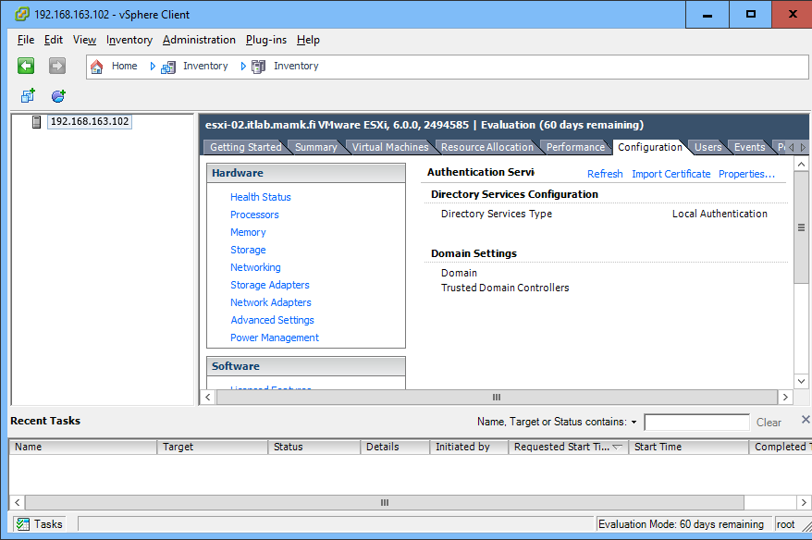

▪ **VM Startup/Shutdown**: check the Properties, you can configure the startup order, delays and priorities for the virtual machines

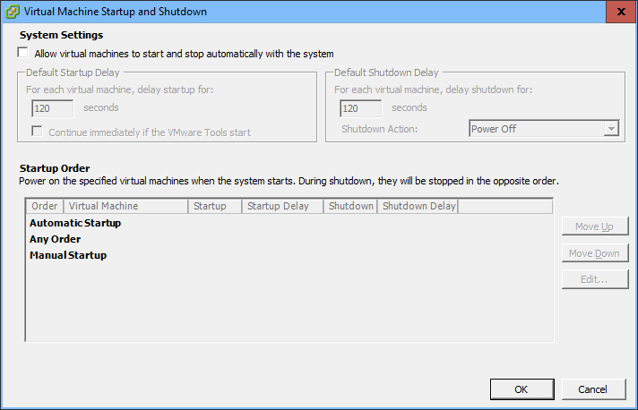

▪ **Security Profile:** firewall rules can be found and configured from here

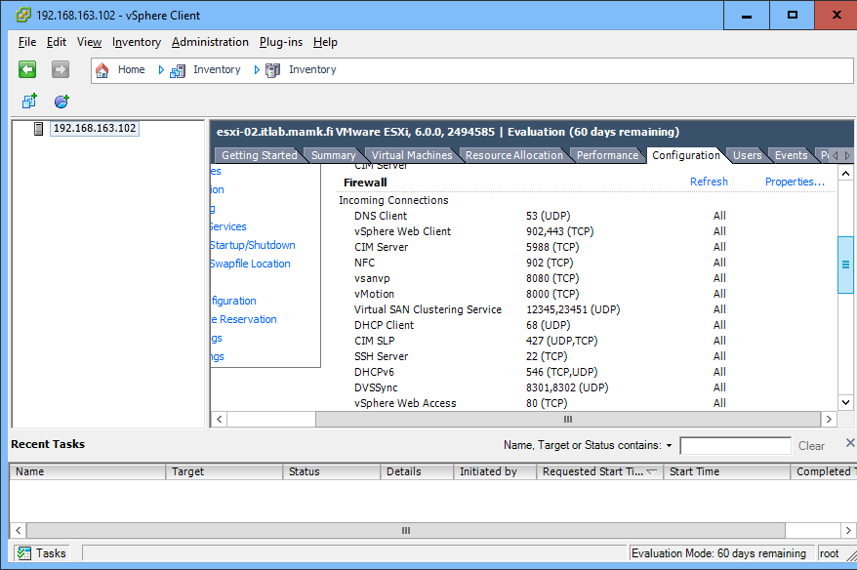

▪ **Advanced**: allows fine tuning EVERYTHING, be careful here!

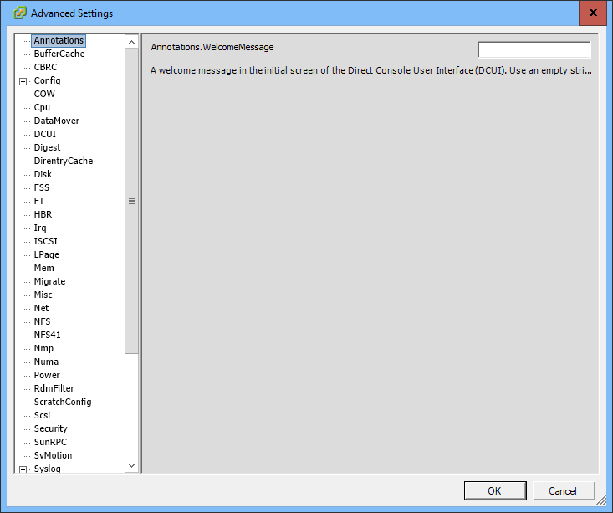

o **Users**: configuration of local users and groups

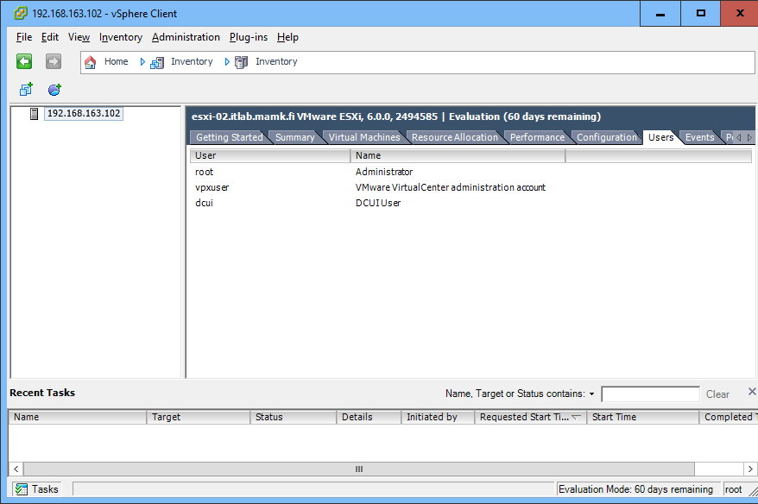

o **Events**: here you can show the system events

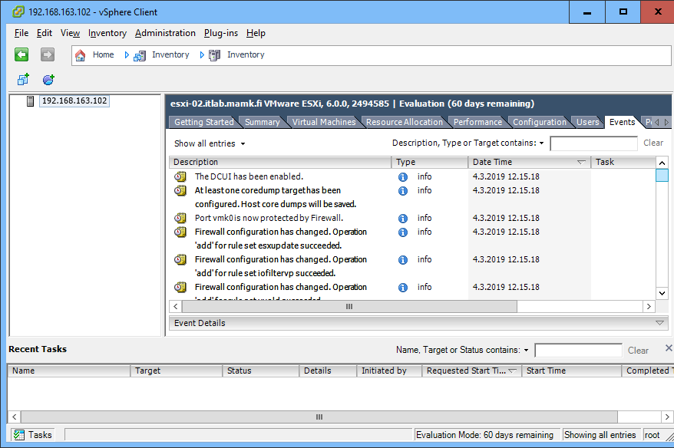

o **Permissions**: configuration of permissions for users and groups

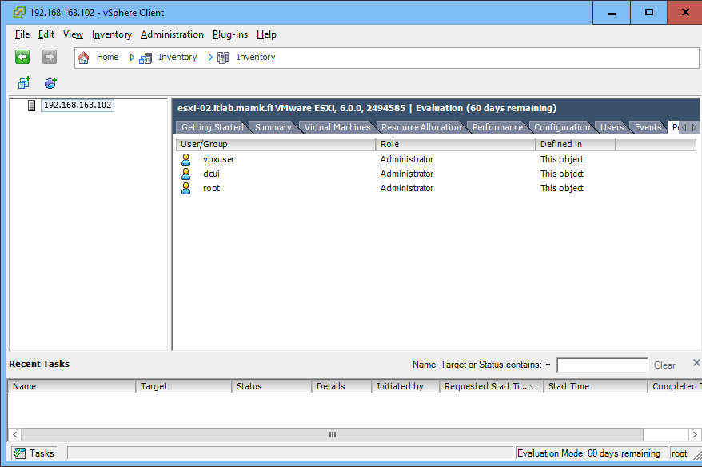

**Step 5. Configuring General ESXi Server Settings with the vSphere Client**

- It is important to keep the server clocks synchronized → configure the **ESXi-02** host to synchronize its clock with the following settings:

o The NTP service starts and stops automatically with the host

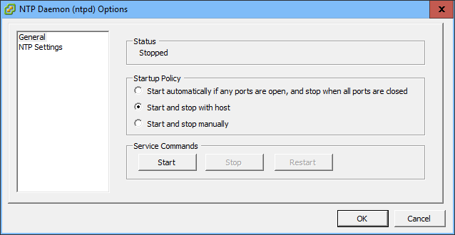

o Use **pool.ntp.org** as the NTP server

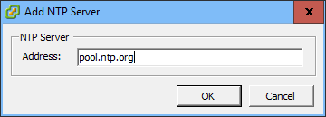

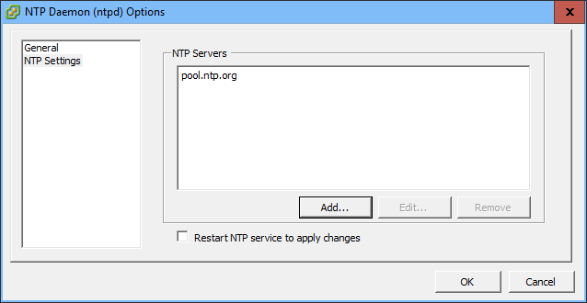

o Ensure that the NTP service is running

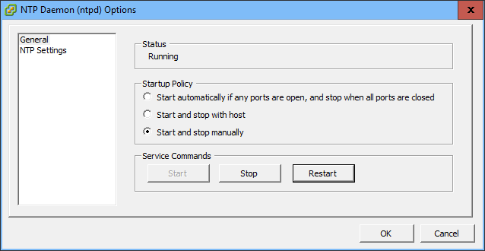

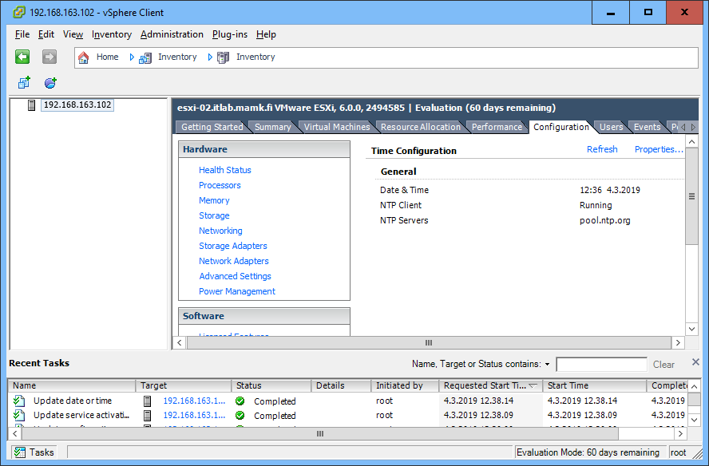

o Also verify from the **Recent Tasks** panel (from the bottom of the vSphere Client window) that the tasks have been completed.

o *Attach a* ***screenshot*** *of the Time Configuration to your* ***report*** *showing that NTP client is configured and running.*

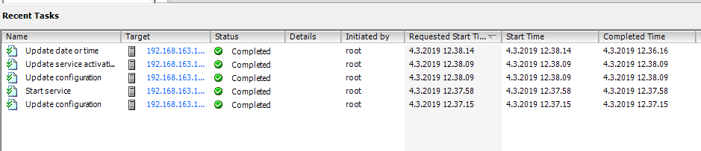

- Just like you did for **ESXi-01**, configure a **datastore** with name **datastore-yourname** for the VMs to the 100 GB HDD

o *Attach a* ***screenshot*** *of the configuration to your* ***report****.*

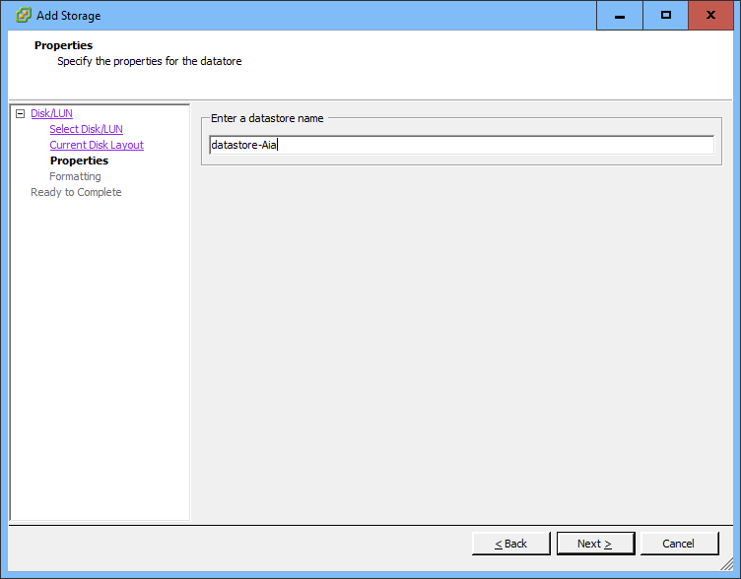

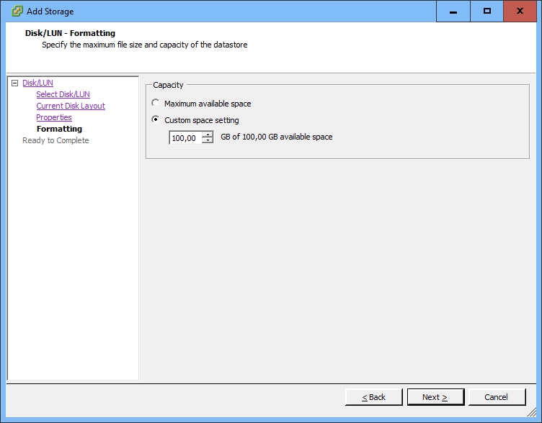

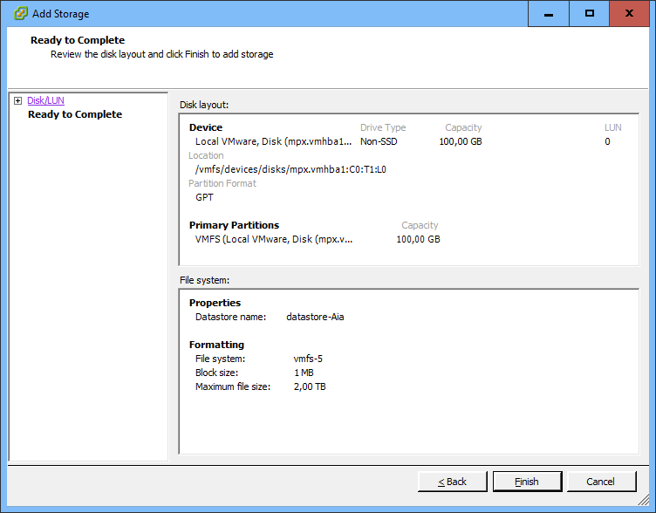

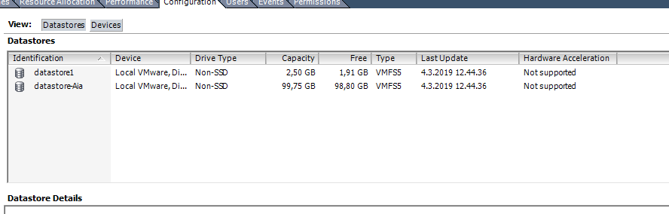

- Just like in **ESXi-01**, the **vSwitch0** is configured by default with only one physical network adapter

o Add the three unused network adapters to vSwitch0

o Use **vmnic3** as a **Standby Adapter**.

o *Attach a* ***screenshot*** *of the* ***NIC order*** *to your* ***report and*** *explain what the standby adapter role means.*

**A: Standby network adapter is a physical network adapter that is used only when one of the other in use network adapters in the NIC team fails.**

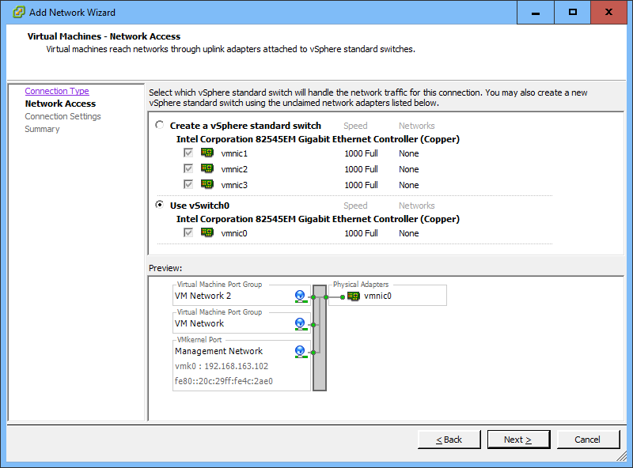

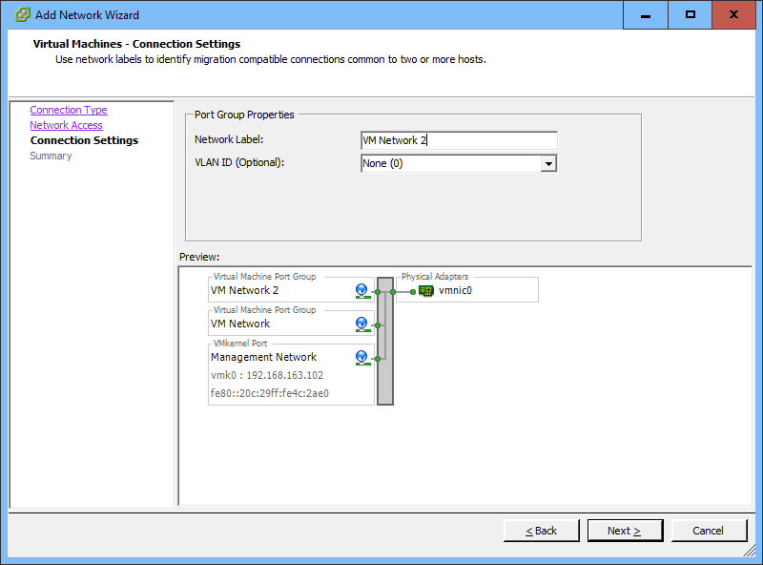

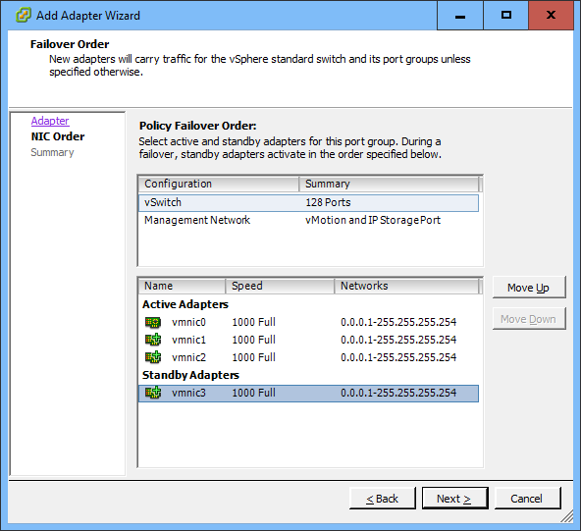

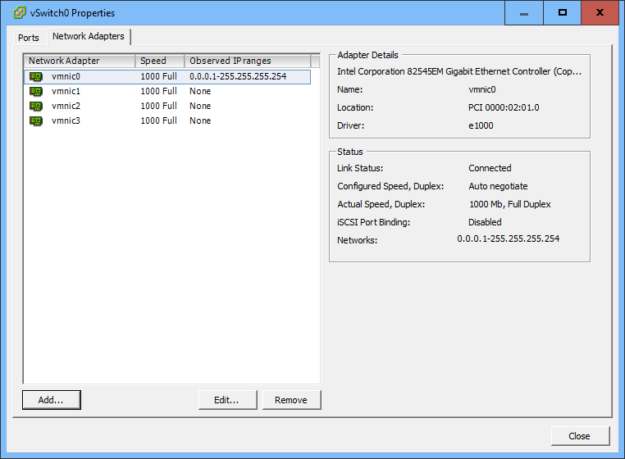

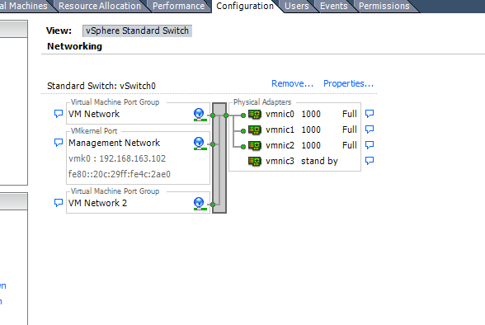

**Step 6. Creating New Virtual Machines with the vSphere Client**

- Create a new virtual machine to the **ESXi-02** host with the following settings:

o Name: **LUbuntu-yourname**

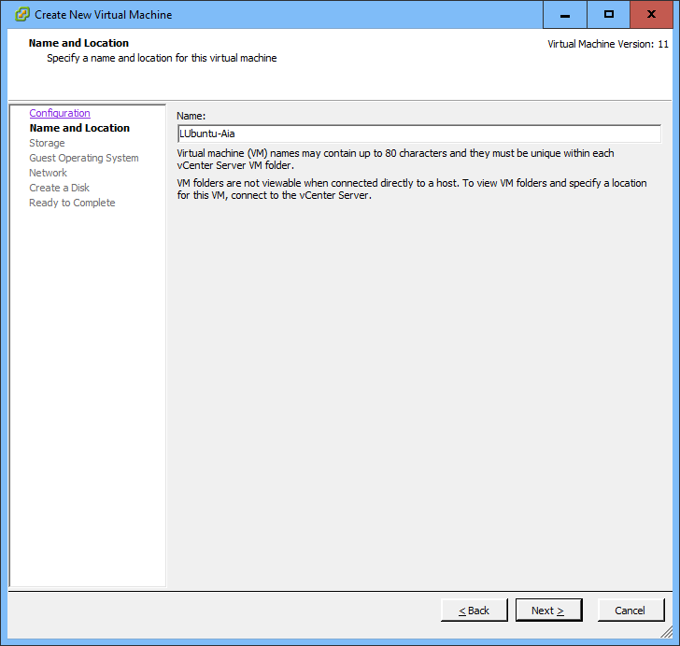

o Storage: **datastore-yourname**

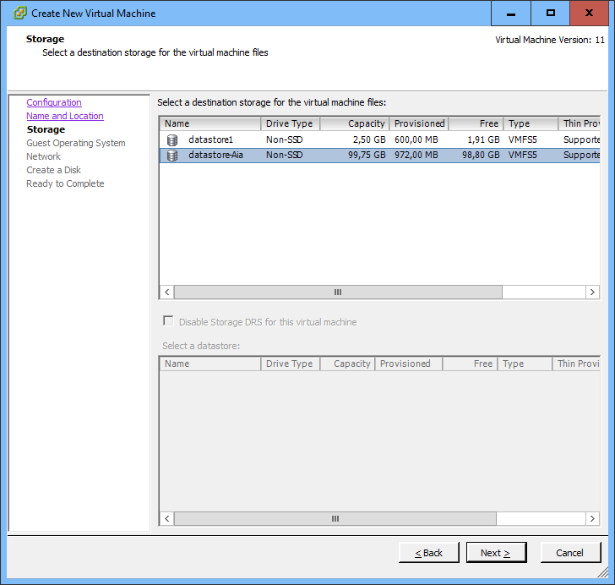

o Virtual disk size: **2 GB**, use **Thin Provisioning**

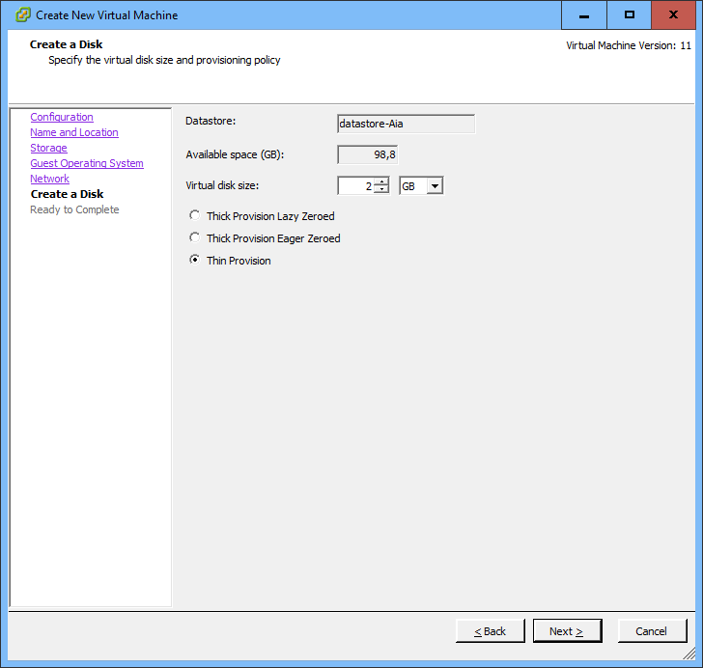

o Edit the **VM Settings**

▪ Change the **memory** amount to **512 MB**

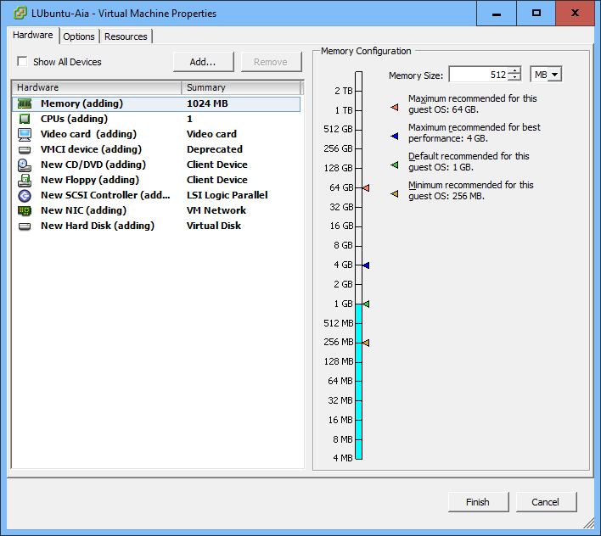

▪ In the **Resource Allocation**, reserve at least **500 MHz** of CPU to the VM

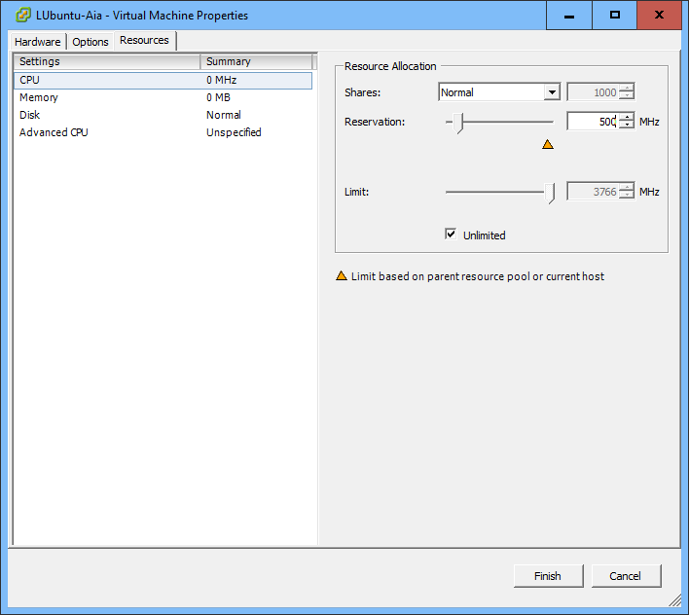

- Open a **Console** window to the LUbuntu VM and power the VM on

o The VM will not boot because there no installation disc mounted in the DVD drive

o You could again upload the ISO file to the datastore, but this time let’s experiment with another way…

o Click on the “**Connect/disconnect the CD/DVD devices of the virtual machine**” button in the Console window and select “**Connect to ISO image on local disk...**” Then browse to P:\Matti\ISO and open an LUbuntu ISO. This way you can directly connect a local ISO image to the VM running in the remote ESXi server.

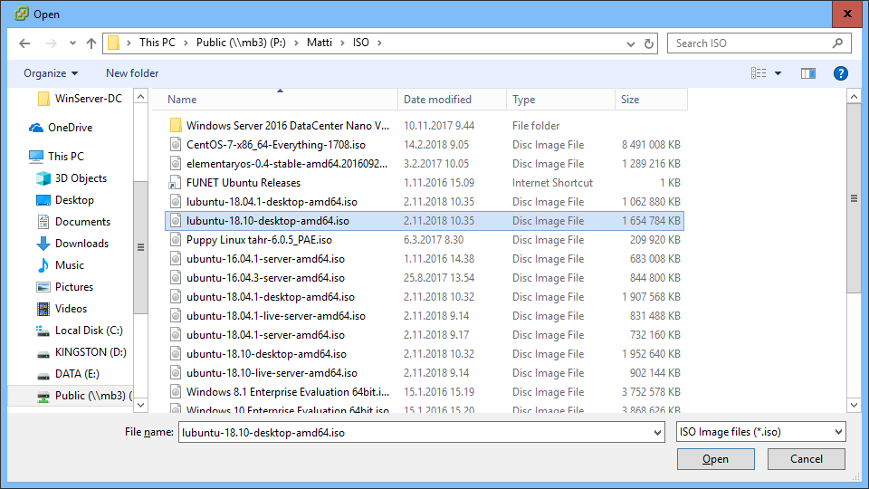

o Then, select **VM** → **Guest** → **Send Ctrl + Alt + Del** (or in the VM window press Ctrl + Alt + Inser) to softly reboot the guest OS in the VM (if you do a hard reset or shut down the VM, the ISO image will be disconnected).

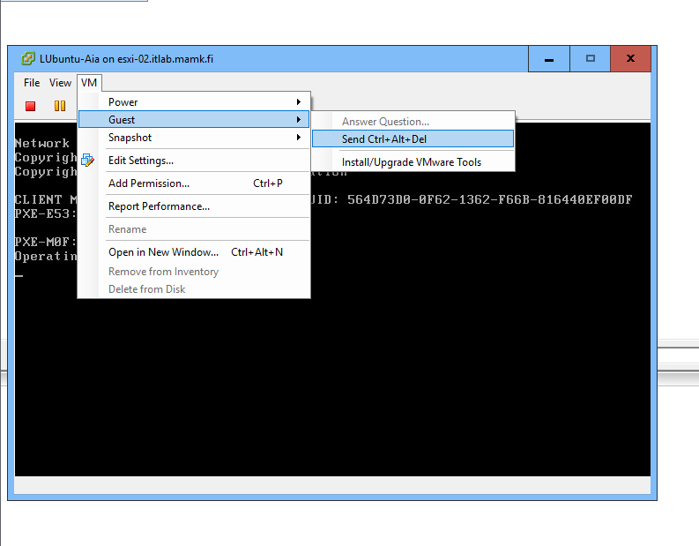

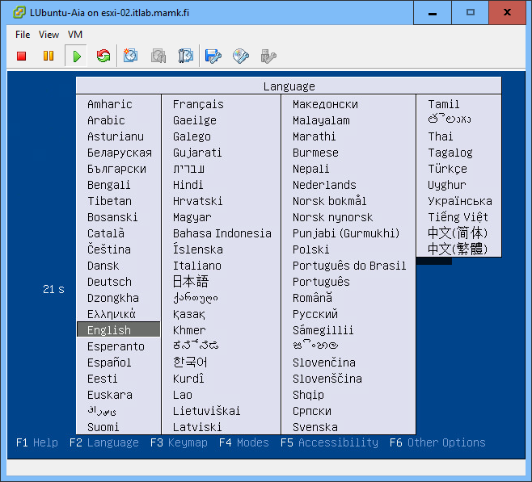

o Now the VM should boot from the local ISO image and you can use the VM through the console.

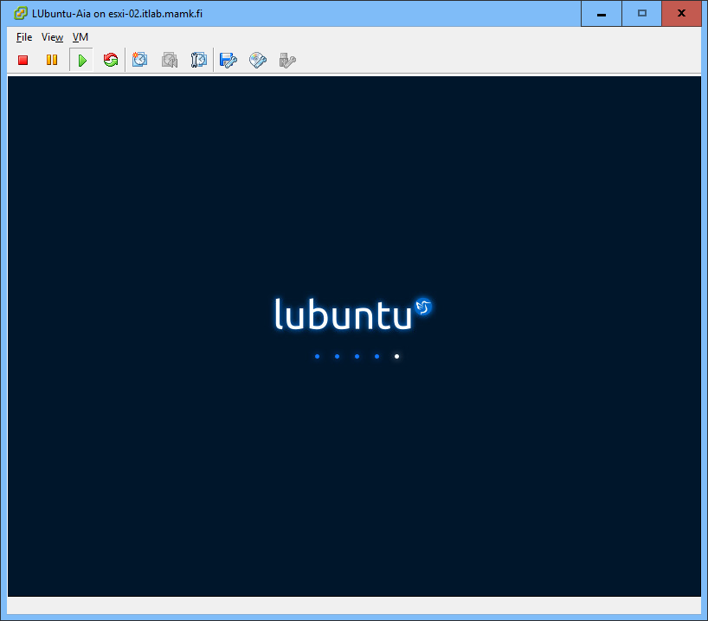

o No need to install anything, just use the LUbuntu live mode…

o Try browsing the Internet with Firefox to verify that everything works fine.

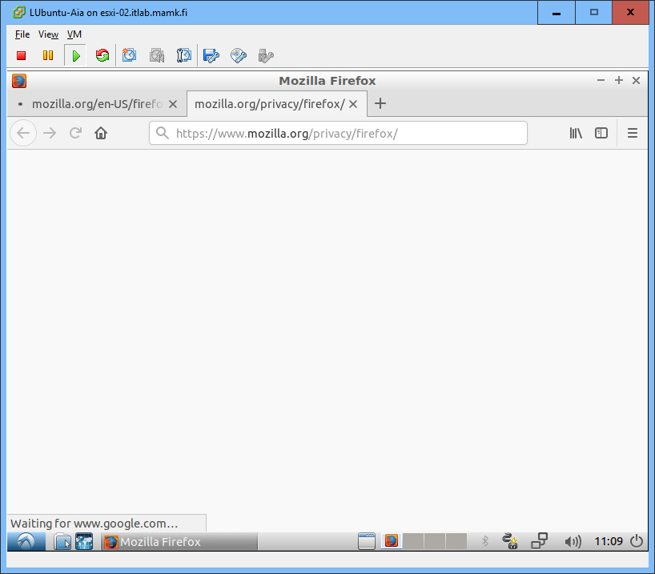

**Step 7. Deploying Virtual Machines from Templates with the vSphere Client**

- Virtual machines can be deployed directly from templates, which makes it possible to prepare a VM image that is quick to deploy into use when needed

o VMware uses OVF (Open Virtualization Format) templates, which include the VM configuration file and the virtual hard disk file. The OVF template can be compressed to an OVA template, which allows archiving all the files into one compressed file.

- Deploy an existing VM image: Select File → Deploy OVF Template

o Source location: P:\Matti\VMware Images\Windows 98 - ESXi OVA Template\ Windows 98.ova

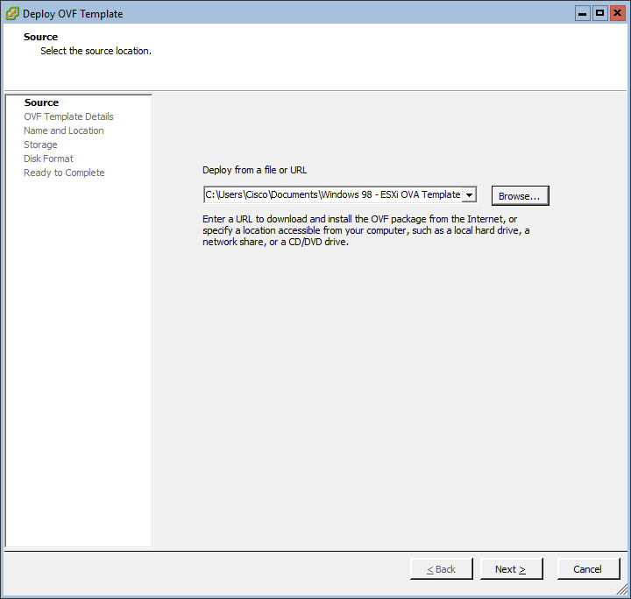

o Check the **OVF Template Details** and notice the VM size and description

o Storage: use **datastore-yourname**

o Disk Format: use **Thin Provisioning**

- When ready, open a **Console** to the new Windows 98 VM, power the VM on and check that everything works.

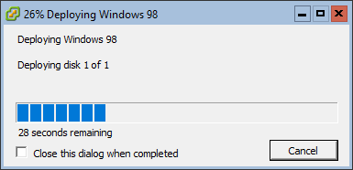

**Step 8. Configuring and Managing Virtual Machines and Server Resources with the vSphere Client**

- You can divide the server resources into logical **Resource Pools**.

o Create a new Resource Pool with name “**RP-ImportantServices**” and with high CPU and Memory resource share.

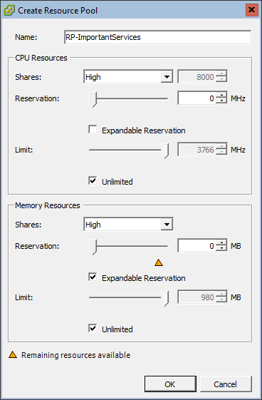

o Create a new Resource Pool with name “**RP-LowPriority**” and with low CPU and Memory resource share.

- Assign your **LUbuntu** VM to the high priority pool and **Windows 98** VM to the low priority pool

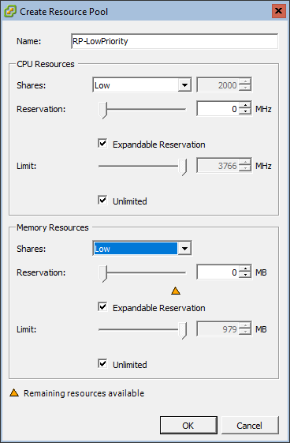

- Assign your **LUbuntu** VM to the high priority pool and **Windows 98** VM to the low priority pool

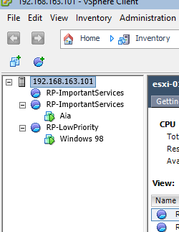

- Explore the **resource usage** in the **ESXi-02** host

o Browse the tabs in the **host level** (select the host IP from the left pane)

* Summary, Virtual Machines, Resource Allocation and Performance

o Then go to the **Resource Pool level** and browse the same tabs

o Then go to the **Virtual Machine level** and browse the same tabs

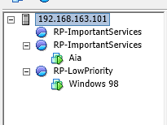

- In the **host level**, go to the Configuration tab and configure the **VM Startup/Shutdown** settings. Change the settings so that

o the virtual machines automatically start and stop with the ESXi server

o the default startup delay for VMs is 60 seconds

o the shutdown action is **Suspend**

o The LUbuntu VM always starts before the Windows 98 VM

o The LUbuntu VM starts 30 seconds after the ESXi host has been started

o *Attach a* ***screenshot*** *of the settings to your* ***report and*** *explain in what kind of situations these settings can be useful.*

**A: The VM can start up and shut down with the host or after a delay. In this way, the operation systems has enough time to save data when the host enters maintenance mode or is being powered off for another reason.**

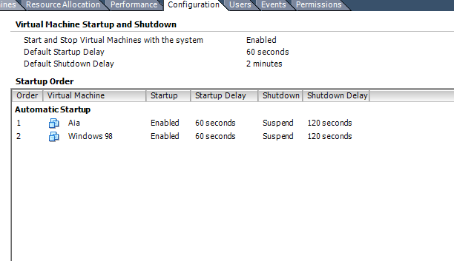

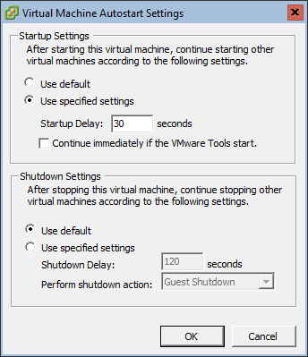

- Practice using the **snapshots**

o Create a new snapshot of the **Windows 98** VM (use your name in the snapshot name)

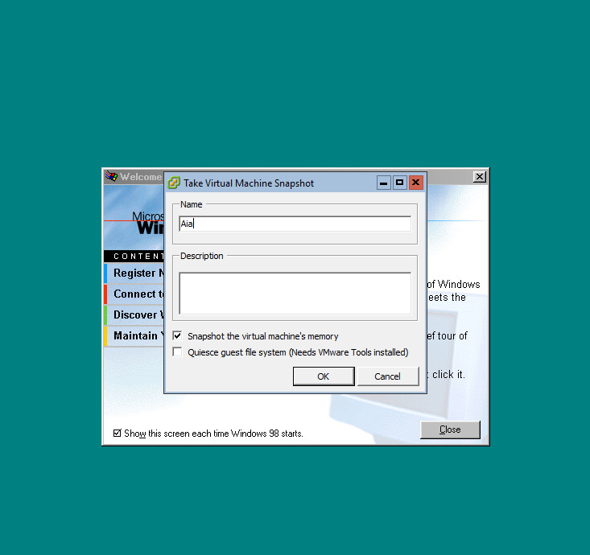

o Do some tasks in the VM (like delete icons from the desktop or change the desktop color) and create another snapshot.

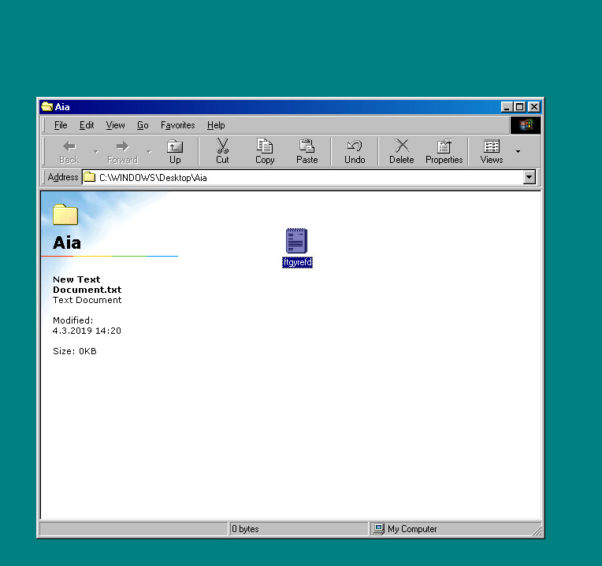

o Open the Snapshot Manager and explore the snapshots.

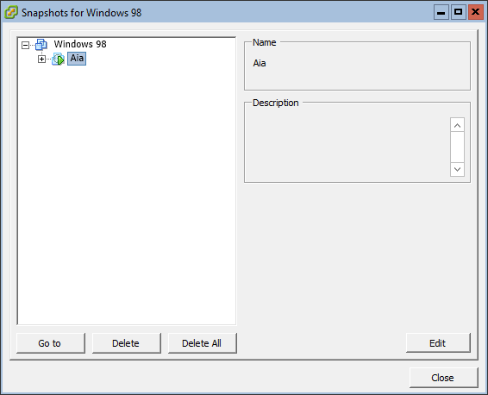

o Practice setting descriptions to the snapshots.

o *Attach a* ***screenshot*** *of the Snapshot Manager showing the snapshots to your* ***report****.*

o Practice reverting the VM to a previous snapshot (undoing the changes you did previously).

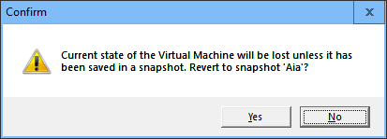

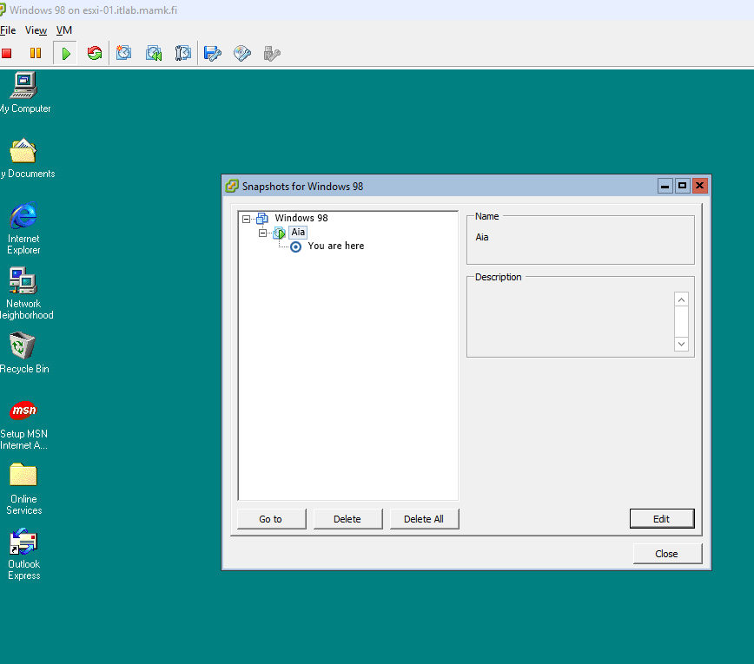

- Shut down the **Windows 98** VM and **export it as an OVF template**

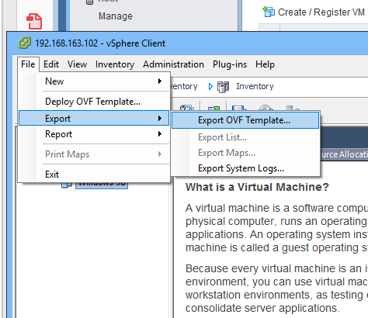

o Change the name to **Win98-YourName**

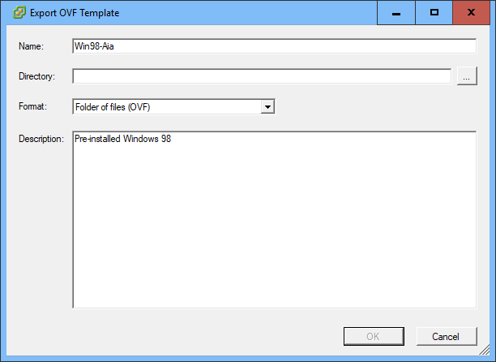

o You can select, which format you wish to use (OVF or OVA)

o Export the VM to some directory in the local PC

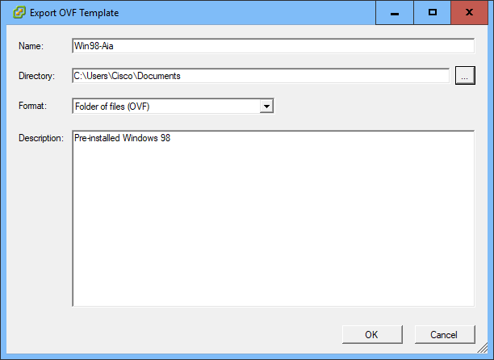

o *Attach a* ***screenshot*** *to your* ***report*** *showing the export process taking place (you can cancel the process after taking the screenshot as you probably don’t need the template in real life).*

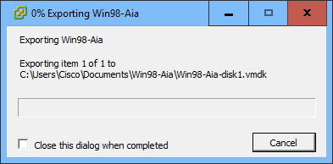

- Select the ESXi

- Download a **performance report** from the ESXi host: select the host IP from the left pane and from the **File** menu select **Report** → **Performance**…

o Use whatever Chart Options you prefer and download the report to the local computer.

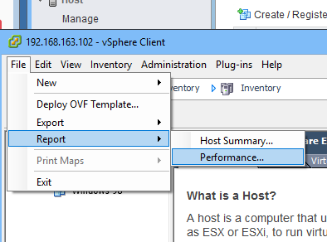

o Open the report with Excel and *attach a* ***screenshot*** *of some report details to your lab* ***report****.*

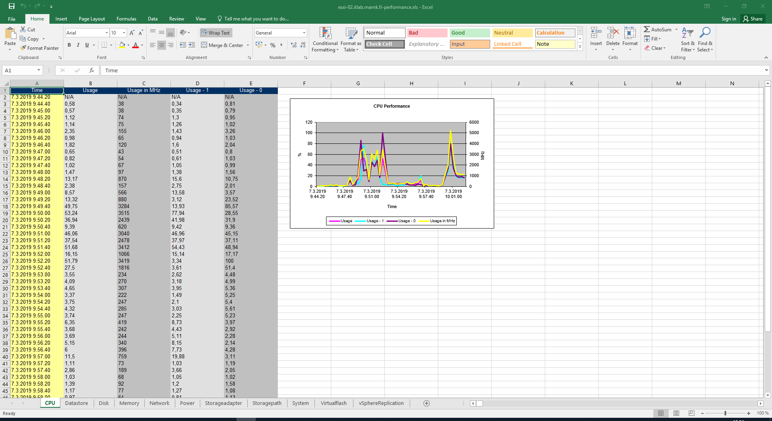

Finally, describe **in your report** your personal experiences about doing the lab and your experiences about VMware virtualization environment.

**A:** **vSphere Client and the vSphere Web Client provide simplest way to manage the ESXi host and operate the VM. It can be used to connect directly to the ESXi host, also it can be used to connect and operate vCenter Server. vSphere can be used to connect to and operate vCenter Server by Web browser. vCenter and host management describes how to start and stop VMware vSphere Client components, build vSphere environment, monitor and manage the information generated about the components, and set up roles and permissions for users and groups using the vSphere environments.**